Novel Approrach to MHP uncertainty in Turbomachinery

Isak Jonsson / Fluid Dynamics Department
Chalmers SE-41296 Sweden

Abstract
Multi-hole pneumatic probes (MHPs) are essential for characterizing complex fluid dynamics, but their precision rapidly degrades in non-ideal, unsteady flow conditions. To address this fundamental vulnerability, this study introduces a novel MHP configuration featuring a Kiel-shaped center port that directly captures true stagnation pressure, bypassing the severe penalties of numerical extraction. Coupled with an adapted data reduction algorithm, the modified probe was experimentally validated in both a steady open jet calibrator and a highly turbulent cylinder wake ($Re = 55,000$). By effectively compensating for unsteady flow dynamics, the novel design mitigated massive uncertainties, yielding up to a two-order-of-magnitude improvement in total pressure accuracy compared to standard setups. This advancement offers a robust, highly accurate solution for demanding turbomachinery and aerodynamic applications.
introduction
MHPs remains an essential tool for characterizing complex fluid dynamics, particularly when evaluating velocity, angles and pressure variations in turbomachinery applications as the single device can measured them all. For decades, studies have been proposing increasingly complex numerical data reduction schemes aimed at minimizing the interpolation or calibration time/error. MHP are often evaluated under ideal, uniform flow conditions. This inherently masks common uncertainties introduced during real-world measurement such as unsteady flows, turbulence and pressure gradients. This research supports some relative new studies that these physical vulnerabilities entirely dominate the error profile, dwarfing numerical interpolation errors, and proposes a novel hardware modification to mitigate the issue.

RESULTS and DISCUSSION
The modified physical probe and its adapted calibration framework were validated in an open jet calibrator and a large-scale wind tunnel cylinder wake study at a Reynolds number of 55,000. The total pressure was measured directly at the center port, and the new data reduction was used to compensate for unsteady flow conditions. This mitigated the massive uncertainty typically observed when conventional MHPs and their associated numerical reduction schemes, are subjected to highly fluctuating, quasi-unsteady environments. Consequently, the novel design yielded up to a two-order-of-magnitude improvement in total pressure accuracy compared to standard MHP setups and meet accuracy of vocality and angles as the reference MHP probe.

This methodology offers the turbomachinery community a robust, high-precision drop-in replacement for standard probes in demanding, real-world flow characterization.

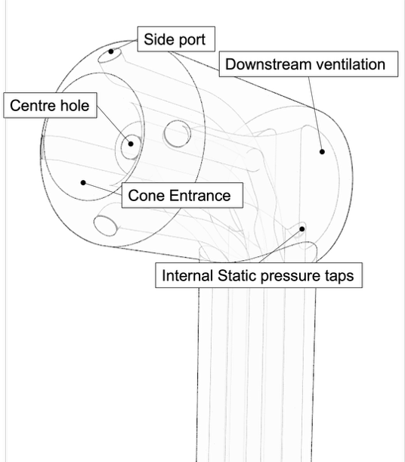
Figure 1. Illustration of a Kiel-MHP probe

