An in-house designed high-fidelity laser Doppler anemometer with unbiased velocity statistics

Clara M. Velte  Department of Civil & Mechanical Engineering  Technical University of Denmark | Preben Buchhave  Intarsia Optics

Abstract
Due to known limitations in software and hardware with commercial systems, an in-house designed laser Doppler anemometry system was designed for high-fidelity turbulence measurements. We have developed analysis methods that provide unbiased temporal and spatial statistics, including dynamic moments such as spectra, correlation functions and structure functions. We also demonstrate the implementation of laser Doppler anemometry in turbomachinery application, where measurements were conducted even between the blades. We will also discuss the faithfulness of tracers in their ability to track the flow.

introduction
Laser Doppler anemometry is known for its high fidelity and accuracy in measurements of fluid flows, including highly turbulent flows [1]. Other measurement techniques, such as hot-wire anemometry, can produce measurements at very high temporal sampling rates, albeit at the cost of intrusiveness, practical challenges with mounting the wire in the region of interest and the inability to distinguish the velocity components in high intensity turbulent flows. Laser Doppler anemometry, on the other hand, requires optical access which may be especially critical in turbomachinery, assumes faithful tracking of the flow and the sampling is random and flow dependent and therefore non-trivial to analyze.
We address these issues herein. We introduce our in-house developed laser Doppler anemometer system [1,2], which in addition addresses many of the known limitations with commercial systems. This system is operating in forward-scattering or side-scattering, which limits the measuring volume to almost spherical and ~30μm diameter. The system uses a 12-bit high sample rate signal digitizer and has the flexibility to optimize filters and signal pre-conditioning for optimum S/N in the Doppler frequency range.
The processing of the bursts to velocities, arrival and residence times is software driven and thereby in principle transparent and facilitating bias-free measurements [3]. Reduction of noise and dead-time effects are also of particular importance in such randomly sampled flows [4-7]. The validation rate of this software-driven system is ~80-90%, while commercial systems typically range around ~40-50%. The processor has an adaptive Doppler signal filtering and we have developed software modules for unbiased statistics from the randomly, yet flow dictated, sampling from the seeding particles passing through the measuring volume.
RESULTS and DISCUSSION
The laser Doppler anemometer has been shown to be able to measure with high accuracy across a radial scan in the fully developed region of a free round turbulent jet. Even in the outermost parts, where the average advection velocity is effectively zero, the measurements still produce the results expected from theory [8-10]. Hotwire anemometers are only able to measure at turbulence intensities of ~20-25% and are thus limited to the region around the jet centerline. We also show the application of laser Doppler anemometry to measurements between the blades in a turbomachine, see Figure 1.

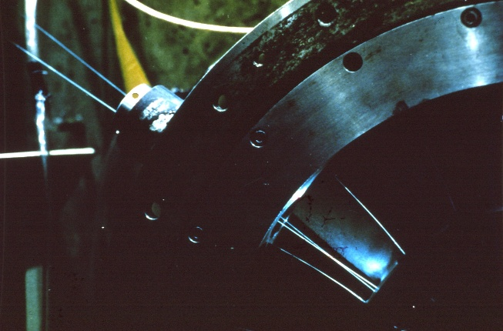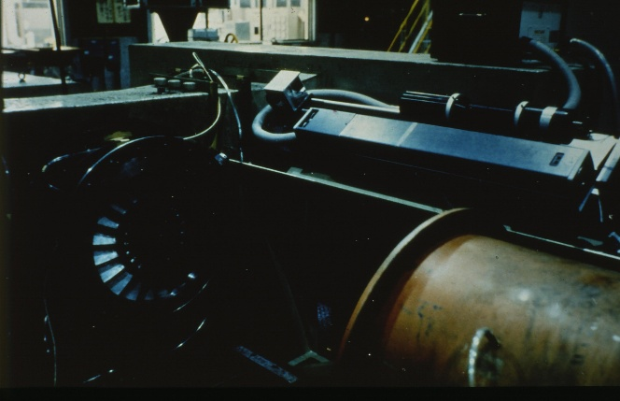
Figure 1. Left: Close-up of laser Doppler anemometry measurements between blades in a turbomachine. Right: Zoomed-out view.
References
[1] Velte, C. M. (2026). Non-Equilibrium Turbulence: A Combined Empirical-Theoretical Approach Toward Improved Understanding in the Post-Kolmogorovean Era. Technical University of Denmark.
[2] Yaacob, M. R. B., Schlander, R. K., Buchhave, P., & Velte, C. M. (2022). A novel laser Doppler anemometer (LDA) for high-accuracy turbulence measurements. Journal of Advanced Research in Applied Sciences and Engineering Technolog, 28(1), 256-274. https://doi.org/10.37934/araset.28.2.256274
[3] Velte, C. M., George, W. K., & Buchhave, P. (2014). Estimation of burst-mode LDA power spectra. Experiments in Fluids, 55(3), Article 1674. https://doi.org/10.1007/s00348-014-1674-z
[4] Buchhave, P., & Velte, C. M. (2015). Reduction of noise and bias in randomly sampled power spectra. Experiments in Fluids, 56(79). https://doi.org/10.1007/s00348-015-1922-x
[5] Velte, C. M., Buchhave, P., & K. George , W. (2014). Power Spectrum Estimation of Randomly Sampled Signals. In Proceedings of the 17th International Symposium on Applications of Laser Techniques to Fluid Mechanics (pp. 11)
[6] Velte, C. M., Buchhave, P., & George, W. K. (2014). Dead time effects in laser Doppler anemometry measurements. Experiments in Fluids, 55(11), Article 1836. https://doi.org/10.1007/s00348-014-1836-z
[7] Buchhave, P., Velte, C. M., & George, W. K. (2014). The effect of dead time on randomly sampled power spectral estimates. Experiments in Fluids, 55(2), Article 1680. https://doi.org/10.1007/s00348-014-1680-1
[8] Buchhave, P., & Velte, C. M. (2022). A similarity scaling model for the axisymmetric turbulent jet based on first principles. Physics of Fluids, 34(9), Article 095102. https://doi.org/10.1063/5.0102809
[9] Zhu, C., Tian, Y., Buchhave, P., & Velte, C. M. (2022). Similarity scaling of the axisymmetric turbulent jet. Physics of Fluids, 34(9), Article 095125. https://doi.org/10.1063/5.0102812
[10] Buchhave, P., Ren, M., & Velte, C. M. (2025). The role of symmetries in the axisymmetric jet mean velocity profile development. Physics of Fluids, 37(8), Article 085176. https://doi.org/10.1063/5.0278023

