Simultaneous Temperature and Concentration Calibration of Pressure Sensitive Paint for Film Cooling Effectiveness Measurements

Dionysis S. Chala  Anestis I. Kalfas | Alexandros Terzis | Beni Cukurel
Aristotle university of Thessaloniki, | Technion - Israel Institute of Technology, | Technion - Israel Institute of Technology,
Laboratory of Fluid Mechanics and Turbomachinery, | Thermo-Fluids and Interfaces Lab, | Turbomachinery and Heat Transfer Laboratory,
Department of Mechanical Engineering, GR-54124,  Thessaloniki, Greece | Department of Aerospace Engineering, IL- 3200003,  Haifa, Israel | Department of Aerospace Engineering, IL- 3200003,  Haifa, Israel

Abstract
Pressure sensitive paints (PSP) are typically calibrated for discrete levels of oxygen partial pressure and temperature. This process can be time-consuming and result in higher levels of uncertainty when fitting calibration points. This study presents a novel calibration setup and methodology for simultaneous observation of continuous temperature and concentration fields over a broad range of oxygen concentrations. PSP calibration is conducted to determine the temperature and oxygen concentration dependency of the examined paint regarding the emitted intensity. The results indicate that intensity-temperature and oxygen concentrations relations can be extracted. The calibration data are validated with the paint manufacturer’s data. The findings show an excellent agreement with the manufacturer’s standards. A detailed uncertainty analysis showed that the typical uncertainty levels are less than 7%.

introduction
PSP is an organic substance with luminescent molecules sensitive to oxygen concentration which emits light when excited. The intensity of the emitted light is affected by the local partial pressure of oxygen as well as the surface temperature. The development of a calibration setup is required to investigate the dependence of PSP intensity on oxygen concentration and temperature. All previous research on the extraction of calibration data has been conducted with the same philosophy. The intensities are measured using experimental calibration setups that can test discrete temperature and oxygen concentration conditions in the painted surfaces.
Cacioli et al. [1] developed a calibration chamber for various pressures and three different temperatures of an aluminum test plate, controlled by vacuum pumps and an adhesive electric heater, respectively. Ahn et al. [2] used a sealed vacuum chamber to perform a PSP calibration at various known pressures and temperatures ranging from 0 atm to 1.8 atm. The PSP intensity was obtained for each pressure and temperature setting. Suryanarayana et al. [3] calibrated PSP in a vacuum chamber using known discrete pressures and temperatures ranging from 0 to 1 atm and 22.2 to 60.1$℃$, respectively. Shiau et al. [4] quantified the relation between partial pressure of oxygen and temperature (which is equivalent to partial pressure of air for a constant concentration of oxygen in ambient air) and the intensity of the PSP painted surface in a vacuum chamber with a transparent Plexiglass on the top section. A copper plate was used as a painted surface and was placed inside the chamber. For temperature measurements, a T-type thermocouple was embedded in the copper, and a flexible heater mat was attached to heat the plate.

ReSULTS AND DISCUSSION
The extraction of the calibration map is possible after capturing the necessary images and correct post-processing based on the calibration procedure. The calibration map of the ISSI UniFIB PSP paint is shown in the Figure 1. The calibration was carried out for a continuous temperature range of 21$℃$ to 36$℃$. The temperature gradient's resolution is determined by the camera's resolution. The pixel size of the camera in this experiment is 30μmx30μm, which results in knowing the temperature value for 30μm intervals. To simulate this temperature gradient upon the copper plate, the temperature difference between two pixels is 0.07 $℃$. The small temperature gradient between the pixels can confirm the assumption that the temperature field is continuous.
Regarding the partial pressures examined in this study, seven points of partial pressures were investigated, five of which were to test sub atmospheric conditions, one case was in atmospheric conditions and the last one was for a pressurized case. A contour of PSP emitted intensity values can be calculated, as shown in Figure.1 The x-axis denotes the partial pressure of oxygen, which is normalized with respect to the reference partial pressure under atmospheric conditions. The y-axis represents the continuous temperature range which was achieved. The intensity of the paint decreases as the partial pressure of oxygen increases, as observed. The same behavior is seen for the paint's temperature sensitivity; as we move from lower to higher temperatures of the calibration copper block, the intensity emitted decreases.

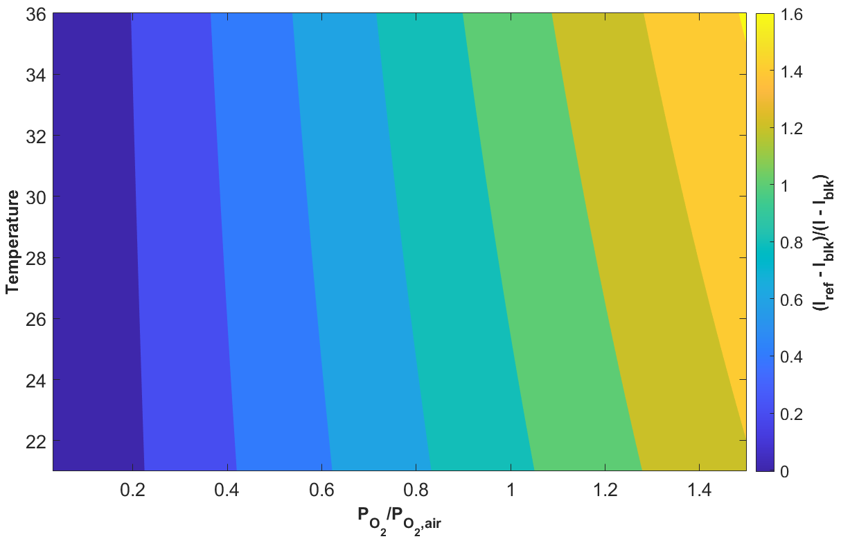
Figure 1. UniFIB two-dimension calibration map

ReFerences
[1] G. Caciolli, B. Facchini, A. Picchi, and L. Tarchi, “Comparison between PSP and TLC steady state techniques for adiabatic effectiveness measurement on a multiperforated plate,” Exp Therm Fluid Sci, vol. 48, pp. 122–133, Jul. 2013, doi: 10.1016/j.expthermflusci.2013.02.015.
[2] J. Ahn, S. Mhetras, and J. C. Han, “Film-cooling effectiveness on a gas turbine blade tip using pressure-sensitive paint,” J Heat Transfer, vol. 127, no. 5, pp. 521–530, May 2005, doi: 10.1115/1.1909208.
[3] A. Suryanarayanan, S. P. Mhetras, M. T. Schobeiri, and J. C. Han, “Film-cooling effectiveness on a rotating blade platform,” J Turbomach, vol. 131, no. 1, Jan. 2009, doi: 10.1115/1.2752184.
[4] C. C. Shiau, A. F. Chen, J. C. Han, S. Azad, and C. P. Lee, “Full-scale turbine vane endwall film-cooling effectiveness distribution using pressure-sensitive paint technique,” J Turbomach, vol. 138, no. 5, May 2016, doi: 10.1115/1.4032166.

