Measurement corrections during spanwise traversing in multistage industrial compressors

V.A Sedunin, L.Xu / University of Cambridge, UK

Abstract
In multistage axial compressors of gas turbine engines there is a need for a detailed understanding of the flow field in between the blade rows, which could be obtained by spanwise traversing. This requires a pneumatic probe to be immersed into the flow path between the blade rows, where the space is limited. Therefore, the probe will affect the flow field around it and in the blade channel, and the probe readings will be affected by that flow field. As a result, these probe readings cannot be translated to flow parameters based on just the freestream calibration characteristics, obtained in the idealized wind tunnel.
In our paper, we provide a computational analysis of the flow field around the cylindrical probe in a constrained inter-blade-row environment at different circumferential locations and flow conditions both upstream and downstream of the stator blade row. It is shown that the flow angle measurement error can reach up to five degrees in the mid-pitch locations compared to undistorted flow, and dynamic head measurements can be up to 30% away from the actual mean values of the flow. These deviations are shown to be caused by flow field interaction inside the blade channel and, as a result, measured values, obtained during industrial compressor testing, could be corrected accordingly. The universal correction procedure is proposed for further use in the industry.

introduction
Nowadays the axial compressor design process in many companies is largely based on the methods of computational fluid dynamics (CFD). When such approach is used, the experimental data is usually available only when the full-scale demonstrator or even the pilot gas turbine engine is manufactured. The latter case is more relevant for heavy-duty gas turbines, especially during modernization and retrofit. For the computationally based approach, it is vital to have refined measurements of the actual flow field in the whole compressor, as this can be used for necessary tuning and can be fed back into the design system.
Experimental study of the full-speed machine brings more challenges in instrumentation and more uncertainties in measurements compared to the low-speed laboratory-scale compressors. This is especially true when spanwise flow measurements are required. The key reasons for that are limited axial spacings between the blade rows, high flow velocities (although, subsonic for most of the stages), and multiple constraints outside the compressor casing, which leaves only certain circumferential positions for the traversing mechanisms to be set. On top of that, when compressor retrofit is desired, the blade count can be changed together with the radial stacking of three-dimensional blades. Therefore, the pneumatic probe location inside the compressor flow path is far from ideal, and the question arises about how this location and the flow conditions affect the probe’s readings.
To answer this question, we analyze the flow field around the cylindrical probe when in proximity to the stator blades, and how this affects the readings. This probe together with its holding stem causes significant blockage and flow re-distribution in the blade channel. The current paper addresses the flow field interaction from the point of view of the probe itself and its interpretation of the flow parameters, rather than the probe’s effect on the blade row performance.
RESULTS and DISCUSSION
When the pneumatic probe is immersed upstream of the stator, it measures the local parameters of the flow, and the difference with representative pitchwise average values is mainly caused by the potential flow field effect, which can be accounted for by doing CFD simulation. However, the measured parameters cannot be treated as true local values since the flow is further complicated by the presence of the probe. The differences between the actual value of the flow and the probe reading can be significant and they can be nonlinear depending on the probe circumferential location and inlet flow conditions.

The main factors causing these uncertainties are:
- the flow asymmetry around the probe with extra acceleration on one of the sides when it is approaching the suction side of the blade,
- downstream flow distortion when the probe is approaching the pressure side of the blade and its leading edge,
- the asymmetry around the probe due to the flow gradient in pitchwise direction and the finite size of the probe, so the sides are exposed to different freestream conditions,
- the interaction with the boundary layer and the wake when measuring downstream of the stator.
To minimize the measurement uncertainties the designer should aim for the middle of the pitch – a region of 20 to 70% was shown to have a narrow spread of the readings in the whole range of explored flow conditions. This could simplify the correction procedure for the measured data. For measurements downstream of the stator similar or 5% wider range can be considered.
Special attention should be paid to high Mach number cases when the uncertainty in dynamic head estimation grows rapidly. For downstream measurements the critical conditions are the high-incidence/high-separation flows when the immersed probe is interacting with the separated boundary layer and significantly changes the flow.
Presented results should help designers to make informed decisions about compressor instrumentation, in particular, the circumferential position of the traversing mechanisms and the good practice for processing the acquired experimental data.
What remains beyond the scope of the present work is the probe behaviour in proximity to the end walls, where the experimental data had shown reasonable agreement with theoretical expectations and computational results, but the uncertainty of these readings remains to be understood and quantified.
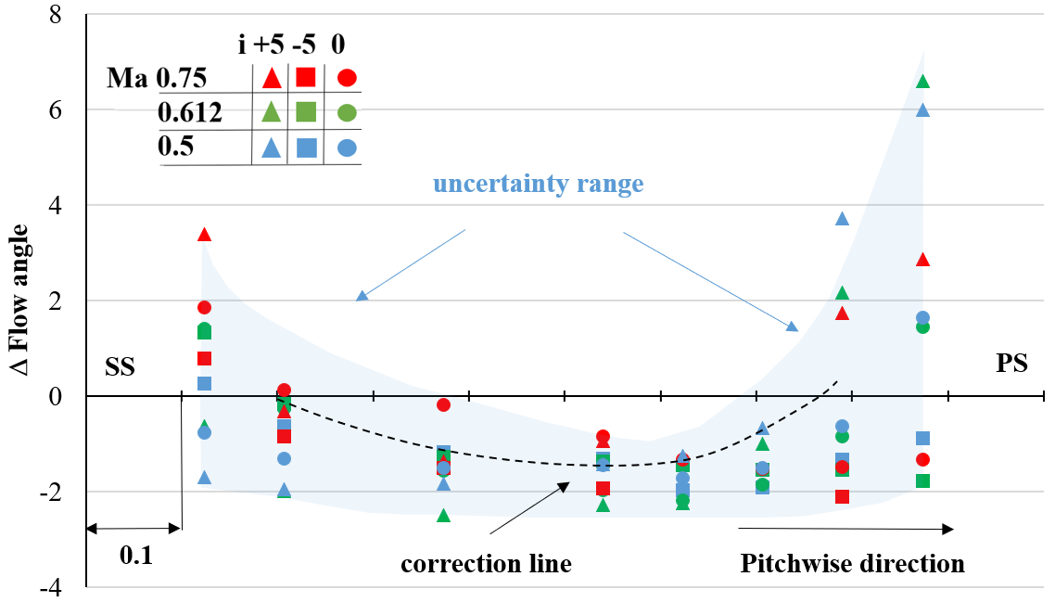

Figure 1. Flow angle measurement comparison with the local value of undisturbed flow along the pitch

References
[1] Dransfield, D. C., and Calvert W. J., 1976, "Detailed flow measurements in a four-stage axial compressor." ASME paper 76-GT-46.
[2] Tweedt D.L., Okiishi T.H., 1983, “Stator Blade Row Geometry Modification Influence On Two-Stage, Axial-Flow Compressor Aerodynamic Performance,” Technical report AD-A141 793.
[3] Lakshminarayana, B. & Suryavamshi, N. & Prato, J. & Moritz, R., 1996, “Experimental Investigation of the Flow Field in a Multistage Axial Flow Compressor”. International Journal of Rotating Machinery. 2. 10.1155/S1023621X96000127.
[4] Ikeguchi, T, Matsuoka, A, Sakai, Y, Sakano, Y, & Yoshiura, K., 2012, “Design and Development of a 14-Stage Axial Compressor for Industrial Gas Turbine” Proceedings of the ASME Turbo Expo 2012: Turbine Technical Conference and Exposition. Volume 8: Turbomachinery, Parts A, B, and C. Copenhagen, Denmark. June 11–15, 2012. pp. 125-134. ASME.
[5] He X., Ma H., Ren M., Xiang H., 2012, “Investigation of the Effects of Airfoil-probes on the Aerodynamic Performance of an Axial Compressor,” Chinese Journal of Aeronautics 25, pp. 517-523.

