Probabilistic Approach for Correction of Five hole probes: Effect of Mach and wall interaction

Lakshya Bhatnagar  Purdue University  Andrea Ruan  Purdue University | Guillermo Paniagua  Purdue University

Abstract
Five-Hole directional probes are commonly used in experimental fluid mechanics to assess flow angles, total and static pressure. Five-hole probes are calibrated to relate these quantities to the pressure readings. This relationship between the pressure reading changes due to the distortion of the flow field and may not be the same as in calibration due to change in flow Mach and Reynold’s number and due to the interaction of the probe and the test section causing local distortion near the sensing holes. These effects, which will be called probe-test section coupling effects, are studied numerically in this manuscript. A correction methodology is developed by analyzing the variation of the pressure change due to these effects. To reduce the number of CFD simulations required for the range of the calibrated angle, a Gaussian regression model is developed and this is used to provide enough data to generate a correction model. This methodology is then applied to an experimental calibration map to correct data taken at Mach number of 0.6 with a calibration performed at Mach 0.2.

introduction
Aerodynamic probes or directional probes are used for the measurement of flow angles (yaw and pitch), total and static pressure with the help of the same probe. They need to be calibrated to relate their raw measurement to derived quantities. However, the calibration process does not consider the effect of probe blockage and the difference in experimental to calibration condition that changes the mapping of the raw measurement to derived quantities. This is important because the calibration is not done in exactly the same flow condition the probes see in the experiment. Gaetani and Persico [1] showed variation of their calibration coefficients for the same value of yaw angle for different Mach numbers. Smout and Ivey [2], [3] showed that the proximity to a wall changed the flow field around a probe and this effect needs to be considered during calibration. The implication of this is that probes must be calibrated in the same duct and at the same operating condition that they will see during a test. This is not always feasible; hence corrections are required for the measured data. Numerical simulations allow us to replicate flow behavior in the experimental test section. In this manuscript a method to leverage numerical data into a simple model for correction of these effects is presented.
RESULTS and DISCUSSION
To better understand the effect Mach number and the proximity of the probe to the endwalls, a numerical analysis was carried out for the directional probe at two different Mach numbers, 7 yaw angles and two different radial locations. Figure 1 shows the coefficient value of C_{pv}, computed as Equation (1), for different value of yaw angle. The values are compared between two Mach numbers and with two different radial locations. It is seen that the C_{pv} values are smaller for higher Mach number. This is due to the additional energy of the flow and its ability to follow greater change in curvature, hence the change in pressure is lower between the yaw holes. This variation in the coefficient value at different conditions incur errors in the angle calculation during a test. These numerical results are used to build a model for correction using Gaussian regression. This model is then used to correct for Mach number effect using calibration data at two different Mach numbers.

 | $${Cp}_{v}=\frac{P_{2}-P_{4}}{P_{5}-P_{avg}}$$ |  | (1)

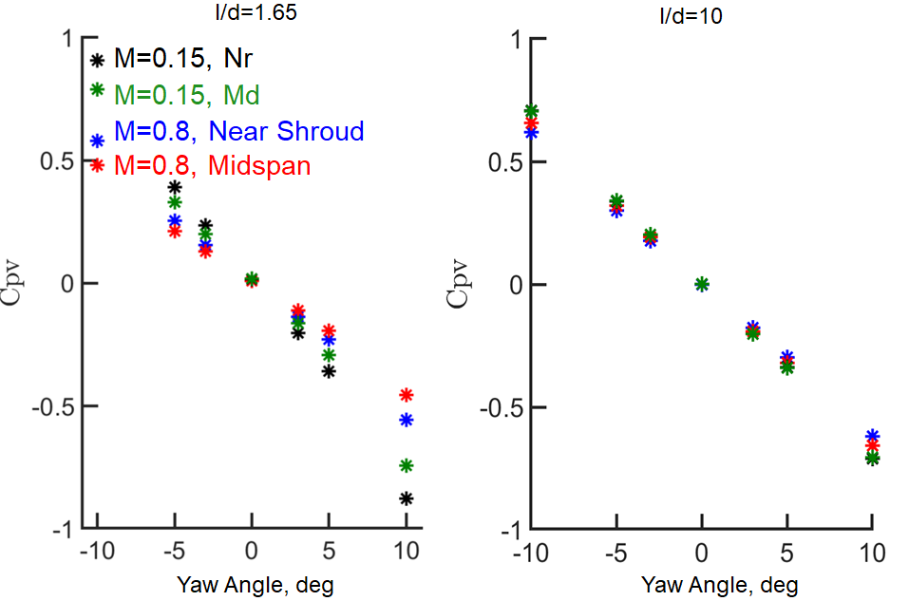

Figure 1. (left), C_{pv} coefficient for l/d=1.65 at four operational conditions, (right), C_{pv} coefficient for l/d=10.

References
[1] P. Gaetani and G. Persico, “Technology Development of Fast-Response Aerodynamic Pressure Probes,” IJTPP, vol. 5, no. 2, p. 6, Apr. 2020, doi: 10.3390/ijtpp5020006.
[2] P. D. Smout and P. C. Ivey, “Investigation of Wedge Probe Wall Proximity Effects: Part 1—Experimental Study,” Journal of Engineering for Gas Turbines and Power, vol. 119, no. 3.
[3] P. D. Smout and P. C. Ivey, “Investigation of Wedge Probe Wall Proximity Effects: Part 2—Numerical and Analytical Modeling,” Journal of Engineering for Gas Turbines and Power, vol. 119, no. 3, pp. 605–611, Jul. 1997, doi: 10.1115/1.2817027.

