Design of a small pressure chamber to evaluate probe calibrations at varying reynolds numbers

Konstantin Speck, M.Sc. | Christian Schäffer, M.Sc. | Prof. Volker Gümmer

Abstract
The Chair of Turbomachinery and Flight Propulsion (LTF) at the Technical University of Munich (TUM) operates a calibration tunnel. A pressure chamber is designed as an addition to the calibration tunnel to enable probe calibration at higher Reynolds numbers. A numerical and experimental evaluation is conducted to describe the design and capability of a cost-efficient adaptation of an existing freestream calibration tunnel for higher ambient pressures and varying temperatures. The design of the freestream calibration tunnel is similar to the design described by Nietsche [1]. The modifications made are less extensive, compared to other pressure chamber modifications like those presented by Gieß et. al. [2].

introduction
The High-Speed Research Compressor (HSRC) at LTF has several traversing slots to investigate the flow within a modern high-pressure compressor rear stage concept. The utilized probes like five-hole probes, total temperature, and total pressure Kiel-probes, fast-response aerodynamic probes (FRAPs), and hot-wires are calibrated at the LTF calibration tunnel with respect to yaw and pitch angle, Mach number, and total temperature.
A preliminary numerical investigation by Schäffer et al. [3] yielded a small dependency of the Reynolds number on the calibration of a five-hole probe. An experimental analysis is necessary to prove the numerical results at lower overpressure. Therefore, a pressure chamber is designed in which the Mach number and Reynolds number can be varied partly independently in a range from ambient pressure up to 200 kPa and Ma numbers from Ma=0.05 to Ma=0.9.
RESULTS and DISCUSSION
The current pressure chamber is optimized for calibrating hot-wire probes at higher mass flow densities and temperatures. Two pressure valves are used for a precise adjustment of the chamber pressure. A manually controlled valve is used for the coarse setting of the chamber pressure. Then, a software-controlled electric valve is sufficient for high precision pressure control.
The setup uses two probes inside the pressure chamber, the probe calibrated, and a total temperature Kiel-probe as a reference, see Figure 1. It was observed that the temperature measurement inside the settling chamber of the calibration tunnel and at the Kiel probe showed significantly different values since the heat loss over the throat and nozzle was not considered before. The Kiel probe is positioned eccentrically and slightly shifted behind the hot-wire. After a design study, numerical simulations with Ansys Fluent are carried out, to ensure the freestream is not influenced by the geometry of the pressure chamber. Additionally, an investigation with five-hole probe, FRAP and hot-wire are conducted. The tests gave a deeper understanding of the flow inside the pressure chamber. The measured data agree very well with the numerical simulations. Several static pressure ports at different axial and circumferential positions allow for the investigation of the change in static pressure and hence the influence on the estimation of the correct Mach number.

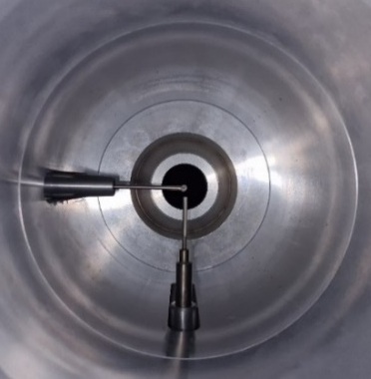
Figure 1: Pressure chamber with two probes mounted

References
[1] Wolfgang Nitsche, André Brunn: “Strömungsmesstechnik” Springer-Verlag Berlin Heidelberg, 2006.

[2] P.-A. Gieß, H.-J. Rehder, F. Kost: “A New Test Facility for Probe Calibration - Offering Independent Variation of Mach and Reynolds Number” Proceedings of the XVth Bi-Annual Symposium on Measuring Techniques in Transonic and Supersonic Flow in Cascades and Turbomachines, 2000.

[3] Schäffer, Christian; Speck, Konstantin; Gümmer, Volker: “Numerical Calibration and Investigation of the Influence of Reynolds Number on Measurements With Five-Hole Probes in Compressible Flows.” Journal of Turbomachinery 144 (9), 2022.

