Particle Image Velocimetry measurement inside axial air test turbine

D. Duda, V. Yanovych, V. Uruba, P. Žitek  University of West Bohemia in Pilsen | M. Němec, T. Jelínek  Czech Aerospace Research Centre in Prague

Abstract
We measure the two dimensional instantaneous velocity fields inside an axial turbine by using the technique PIV (Particle Image Velocimetry). The measured plane is located just behind the rotor wheel and it is oriented in axial × tangential direction. We measured a single overloaded regime as well as the nominal one at middle-height and tip radii. We discuss several technical difficulties appearing during this measurement, mainly with the seeding particles and with the optical access into a massive steel body. The timing of the PIV system is synchronized with the rotor; therefore, we can study the wakes past rotor blades statistically.
introduction
Among the variety of methods for measuring flow velocity, the technique of Particle Image Velocimetry (PIV) [1] offers the spatial resolution of the instantaneous velocity field, which is advantageous for studying the coherent structures of turbulence. PIV is an optical method, therefore it does not disturb the flow by any probe, but on the other hand, it needs seeding particles, whose motion is measured. The need of optical access from two directions (for illumination laser and for camera) makes its use difficult for in-situ measurements.
RESULTS and DISCUSSION
The synchronization of PIV system and rotor wheel rotations allow to study the average pattern of the rotor wake. The instantaneous data show large amount of vortices of size about the shear layer thickness and the spatial spectrum follow the Kolmogorov scaling for homogeneous and isotropic turbulence under that size. We had several troubles with the condensation of seeding particles on the glass between the diffuser and main body. Best quality result was obtained without this glass, but its removal changes the geometry. In our contribution we focus to the effect of a such rude change to the trustworthiness of the results.

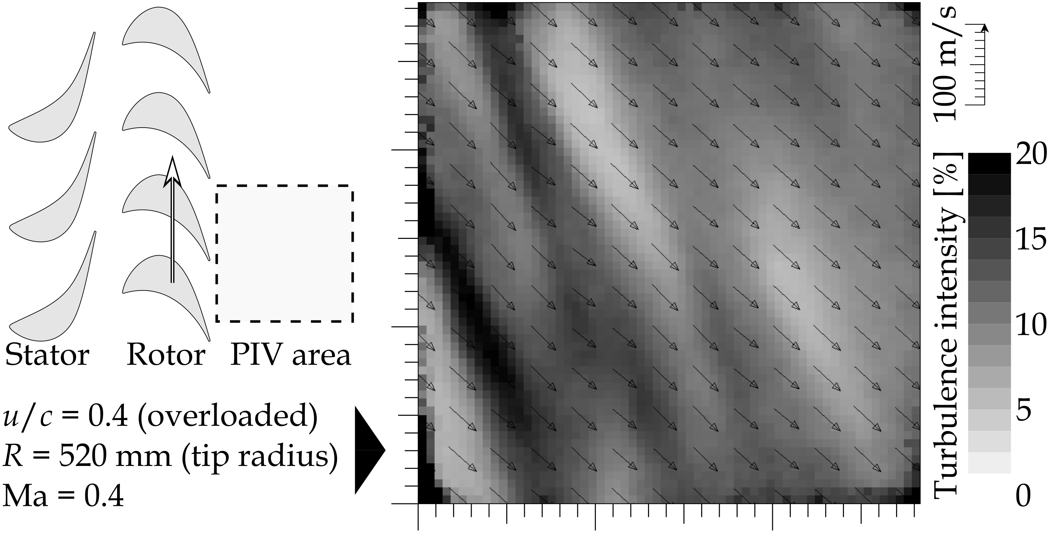

Figure 1. Ensemble average of 657 velocity fields measured at the tip plane at overloaded conditions just behind the rotor wheel (which is behind the left edge of this figure) The field-of-view size is 28 mm. The grayscale represents turbulence intensity based on in-plane velocities. Only every 5th vector is plotted.
References
[1] C. Tropea, A. L. Yarin, and J. F. Foss, “Springer handbook of experimental fluid mechanics” (2007)

