SHock Wave BOundary Layer interaction measured by PIV and HIgh-Speed Schlieren ON the suction side of a Transonic Turbine cascade

Marcel Börner, Reinhard Niehuis
Institute of Jet Propulsion
Bundeswehr University Munich
marcel.boerner@unibw.de
Neubiberg, Germany

Abstract
Recalling the prospective regulations to reduce the fuel consumption of air traffic, the efficiency of jet engines needs to be improved. One approach in order to target the total efficiency improvement is the increase of the spool speed of the low-pressure turbine. With the benefits of higher flow speeds in the turbine come drawbacks like shock waves and unsteady interactions with the boundary layer, which produce additional profile losses. Although the research on shock wave boundary layer interactions (SWBLI) is already in focus of many research projects for many decades [3], not all phenomena are fully understood, yet, and a deeper investigation is necessary.
For this reason, the experimental results of a linear transonic turbine cascade with SWBLI are presented. The suctions side flow is investigated with two different measurement methods at high subsonic exit Mach numbers and at engine relevant Reynolds numbers. On one hand, the velocity field and the turbulent quantities from time-averaged PIV measurements and, on the other hand, visualization of shock wave positions by high-speed Schlieren recordings are discussed within the following paper. The Schlieren recordings reveal a complex shock wave system with a terminating normal shock wave and several compression and expansion waves upstream. The shock waves highly interact with the separated boundary layer and influence the transition process. Finally, these lead to reattachment of the flow. The unsteadiness of the separation bubble and the interacting shock waves were already published by Börner and Niehuis [1]. High-speed Schlieren images together with surface hot-film sensors at the suctions side surface were evaluated within this publication. Characteristic frequencies $S_{L}<0.2$ related to the separation length were found. The lower frequencies around $S_{L}≈0.05$ correspond to the shock wave movements itself. The connection of the also found higher frequencies to vortex shedding from the shear layer could not be proven, yet. Although, the flapping motion of the shear layer visible from the Schlieren recordings supports the evidences.
The PIV measurements in the paper presented here are focused on the shear layer flow and are compared to the shock wave positions from the Schlieren images. Furthermore, the distribution of the local turbulence intensity is discussed, which is also calculated from the fluctuating velocity quantities obtained by the PIV measurements. The applicability of PIV for turbulence measurements in the high-speed cascade flow was successfully demonstrated by Chemnitz and Niehuis [2]. Unfortunately, almost no seeding particles were found within the separated boundary layer close to the surface, which makes it impossible to gain reliable boundary layer parameters. Nevertheless, the thickness of the separation as well as the position of reattachment of the flow are measurable. For this purpose, another detailed investigation using a zoomed-in PIV setup of the rear part of the profile blade is presented.

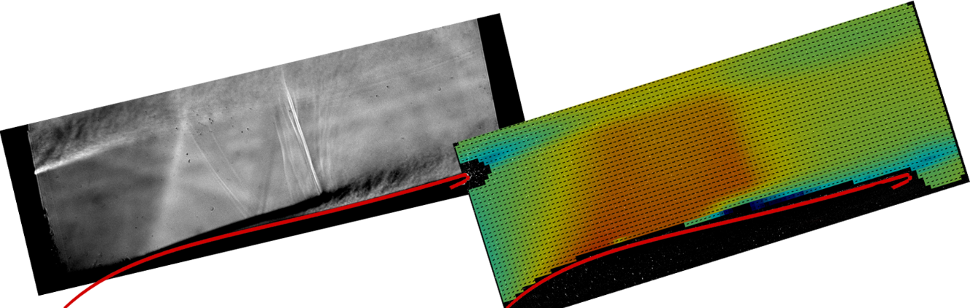

Figure 1. Comparison of a single Schlieren image (left) and average velocity field from PIV (right). Red line marks part of the suction side surface of the turbine profile. Flow from bottom left.

REFERENCES
[1] Börner, M., Niehuis, R. (2020) Dynamics of Shock Waves Interacting With Separated Transonic Turbine Flow Investigated by High Speed Schlieren and Surface Hot Film Sensors. In: ASME Turbo Expo 2020: Turbomachinery Technical Conference and Exposition, GT2020-14386.
[2] Chemnitz, S., Niehuis, R. (2020) A comparison of turbulence levels from PIV and CTA downstream of a low-pressure turbine cascade at high-speed flow conditions. J. Turbomach., 1–14.
[3] Dolling, D.S. (2001) Fifty Years of Shock-Wave/Boundary-Layer Interaction Research: What Next? AIAA J 39, 1517–1531.

