Development of a Test Stand for Electric Fuel Cell Turbocharger Integrity Testing

Georgios Karakasis  IHI Charging Systems International | Sebastian Kunze  IHI Charging Systems International | Georgios Iosifidis  IHI Charging Systems International | Anestis Kalfas  Aristotle University of Thessaloniki

Abstract
Hydrogen fuel cell technology is identified as a key technology for a carbon-free society. It provides a great balance between environmental impact, power density, powertrain manufacturing costs and lastly total cost of ownership. Like an internal combustion engine, a fuel cell system requires a specific supply of oxygen. Known technologies, such as an electrical turbocharger comprising a compressor and turbine stage as well as an electric motor can be used to deliver the required amount of air to the fuel cell. It is necessary to supply the fuel cell with pressurized air to increase the total system efficiency [1]. Including a turbine stage on the charging system, the electrical power provided to the compressor stage can be reduced by up to 30%, increasing the total system efficiency drastically [2]. The presented paper provides an overview of a test bed construction to simulate the air and liquid water conditions of a Proton Exchange Membrane (PEM) fuel cell exhaust. Also, this test bed will be used to investigate the impact of these conditions on a fuel cell charging system with an aluminum turbine alongside the necessity and performance of water separators.

introduction
A global goal that has been set by the Paris convention is to reduce the global CO₂ emissions. The mean earth’s temperature has been on a steady incline from the year 1930 [3] with the critical 2ºC ceiling being ever so close. Dividing the global emissions in sectors we can identify the transportation sector as a leader, surpassing the public energy and heat production [4]. IHI is assisting in global power generation with renewable energy. Renewable energy does, unfortunately, come with the problems of poor density, high production costs and environmental detriments. These environmental detriments range from huge changes to landscape being mandatory for the transportation and installation of equipment such as wind power to changing the flora and fauna ecosystems because of dams for hydropower plants. For these reasons, IHI has been investing into hydrogen technology not only for transportation of medium to large vehicles but also general transportation such as marine and aviation. Also, IHI with the collaboration of global partners is developing a pathway to ammonia production, storage and usage.
RESULTS and DISCUSSION
Constructing a test cell add-on for characterizing droplet separators while also being able to cause erosion of the turbine stage of a PEM fuel cell charging system was successful. Two types of separators have been tested, here denoted as “Type A” and “Type B”, each one based on a different function principle. Characterizing separators showed that Type A has the best separation efficiency when considering the full operating range of the fuel cell charging system. Their downside is the relation between separation efficiency and air leakage through the drain orifice which reduces the overall efficiency of the complete system. Type B separators showed good separation efficiency at low air mass flows but faced a sudden drop when increasing the main air mass flow. The advantage that Type B separators have over the Type A is that minimal amount of air can escape through the drain. The pressure drop of each unit is similar, so separation efficiency is the dominant contender for evaluation. Erosion on aluminum radial flow turbine wheels has been investigated in literature, showing similar results with the experiments conducted on the testbench. Aluminum radial flow turbine wheels with guide vanes do not show similar erosion patterns; this is most likely caused by droplet-to-droplet or droplet-to-surface interactions. It also appears that certain droplet sizes affect the turbine wheel differently than others. Extremely fine particles skip the surfaces and leave through the outlet, medium droplets impact the wheel while very large droplets accumulate on the volute, bursting into smaller droplets that in turn impact the turbine wheel. It is shown that erosion on the turbine stage, although inevitable, is not detrimental to the lifecycle as it might appear at first glance. A lot of time must elapse for the water droplets to cause critical damage to the turbine stage for the integrity of the system to be compromised. The amount of time for these phenomena to act might be twice or three times the life expectancy of the whole fuel cell system.

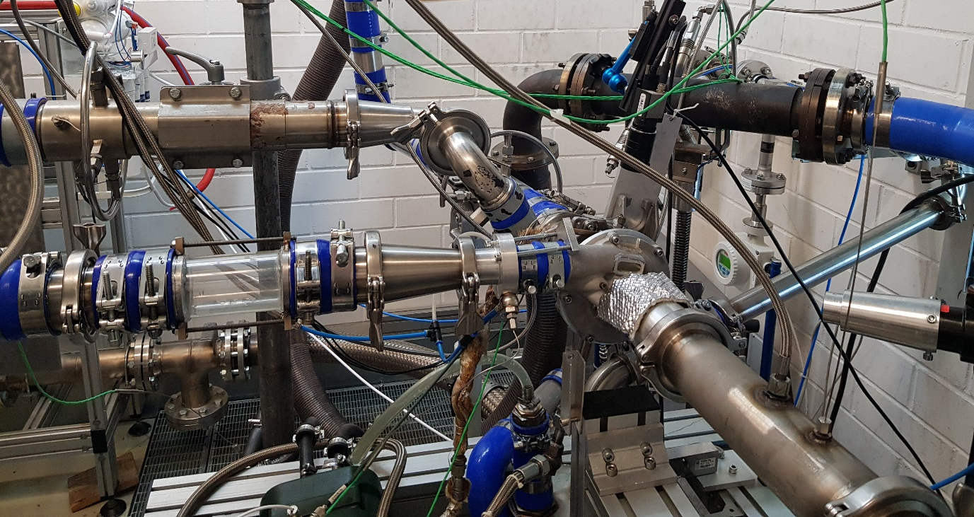
Figure 1. Turbocharger setup

ACKNOWLEDGEMENTS

The research program “BZ_Turbolader" is funded by the German Federal Ministry for Economic Affairs and Climate Action under the grant number 19I21046A.

The authors are grateful for the financial support.

References
[1] Q. Yan, H. Toghiani, H. Causey, “Steady state and dynamic performance of proton exchange membrane fuel cells (PEMFCs) under various operating conditions and load changes”
[2] D. Filsinger, G. Kuwata, N. Ikeya, “Tailored Centrifugal Turbomachinery for Electric Fuel Cell Turbocharger” 2021
[3] NASA, “World of Change: Global Temperatures” 2020
[4] I. Tiseo, “Greenhouse gas emissions by aggregated sector” 2019, retrieved from: Greenhouse gas emissions worldwide - Statistics & Facts | Statista

