Design of a High-Temperature Regenerated Brayton Heat Pump Test Rig

Matteo Benvenuti¹ | Guido Francesco Frate¹ | Paolo Taddei Pardelli² | Lorenzo Ferrari¹
¹Department of Energy, Systems, Territory and Constructions Engineering (DESTEC), University of Pisa, Italy
²Spike Renewables Srl, Florence, Italy

Abstract
This paper aims to dimension a test rig of a high-temperature regenerated Brayton heat pump, which provides heat at more than 130°C, using small-sized and off-the-shelf components. This facility will enable the testing of a Brayton heat pump system and its components, with the final goal of validating several related models, highlighting the technology's essential features, and fostering its wide deployment in the industry.
introduction
High-temperature heat pumps have the potential to play a crucial role in decarbonising the heat demands of the industrial sector [1]. Heat pumps based on the Brayton cycle have gained increasing attention, especially for applications above 150°C – 200 °C [2].
One of the primary challenges of this work is ensuring compatibility between project requirements and the technical specifications of the components available on the market. Moreover, the test rig is designed to promote flexibility and allows testing of four distinct operating conditions for the heat pump: closed- and open-loop, regenerated, and non-regenerated. With a set of valves, it is possible to bypass the regenerative heat exchanger, transitioning from one operational state to another. In contrast, open loop operation is achieved simply by disconnecting the turbine outlet from the compressor inlet.
Eventually, the cycle can operate alternatively with an expansion valve or a turbine for the expansion phase.
RESULTS and DISCUSSION
Based on what is available on the market and considering the main limitations of turbomachinery, the thermodynamic cycle will evolve with a maximum temperature of 135°C and a maximum pressure ratio of 2.1, depending on the chosen cycle configuration.
Two compressors for applications related to fuel cells [3] and a turbocharger [4] from the automotive sector were selected. A turbocharger was employed instead of a single turbine due to its market availability to realise the test rig. Additionally, the turbine's characteristics influenced the choice of two parallel compressors to handle the required air flow rate. The selected machines are reported in Table 1.

 | Name | Nominal power [kW] | Test rig power [kW] | Air flow rate [kg/s]
Turbine (turbocharger) | Garrett GBC14-200 | N/A | 5 | 0.11
Compressor (x2) | Rotrex EK10C-0822 | 13 | 5.5 | 0.05
Table 1 – Turbomachine data. The compressor’s data refer only to a single compressor since the two are identical
Once the test rig's operating conditions and components are selected (see Figure 1), the paper focuses on the coolant system design, which is needed to dissipate the heat pump's output but also to cool the auxiliary components, such as the lubricant oil for the compressors and the compressors' inverters. A closed-loop coolant liquid circuit is proposed to simplify the test rig, simultaneously operating all heat exchangers and dissipating excess heat into the environment. Seven heat exchangers are connected in parallel to the collectors, with five increasing the coolant temperature and two reducing it. The heat exchangers' capacity is reported in Table 2.

 | Heat [kW] | UA [W/K]
Heater | 2.51 | 77.7
Cooler | 8.93 | 213.0
Regenerator | 2.63 | 146.4
Radiator | 43.5 | 2364.0
Table 2 – Heat exchangers data
(a)
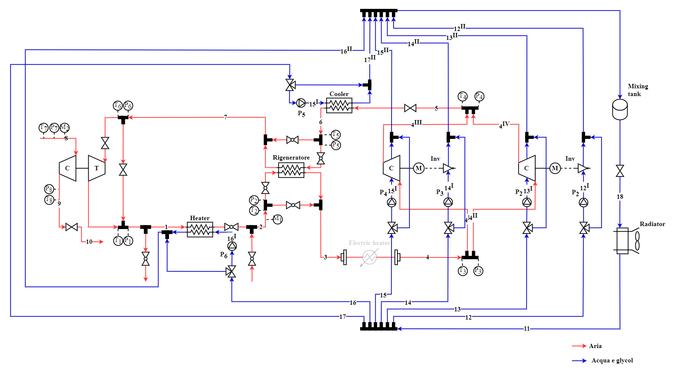
(b)
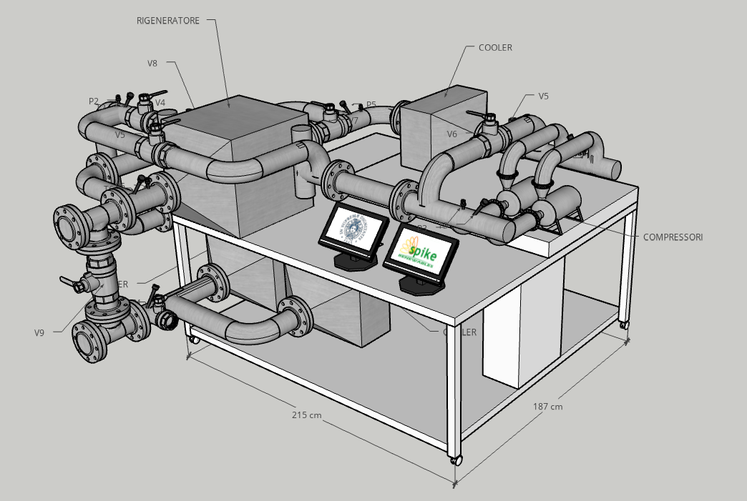
Figure 1. (a): Test rig scheme with measurement points; (b): Test rig 3D rendering.
References
- Arpagaus, Cordin, et al. "High Temperature Heat Pumps: Market Overview, State of the Art, Research Status, Refrigerants, and Application Potentials." Energy, vol. 152, 2018, pp. 985-1010.
- Zühlsdorf, B., et al. "Analysis of Technologies and Potentials for Heat Pump-based Process Heat Supply above 150 °C." Energy Conversion and Management: X, vol. 2, 2019, p. 100011.
- https://rotrex-fuel-cell-compressor.com/fuel-cell-compressors/
- https://www.garrettmotion.com/it/racing-and-performance/performance-catalog/turbo/garrett-boost-club-line-gbc14-200/

