measurement of coherent flow instabilities in the wake of a compressor blade at high incidence angles

Petr Šidlof  Technical University of Liberec, NTI FM, Studentská 2, Liberec, Czech Republic | David Šimurda, Jan Lepicovsky  Institute of Thermomechanics, Czech Academy of Sciences, Dolejškova 5, Prague, Czech Republic

Abstract
The study reports on preliminary measurements of coherent instabilities in the separated flow downstream of blade with a transonic compressor profile, registered by Kulite dynamic pressure transducers mounted in the blade surface. For the sake of future investigation of non-synchronous vibration, the frequency and amplitude of the spectral peak was analyzed for various blade incidence angles and inlet Mach numbers.

introduction
In the highly loaded bladed disk assemblies of turbomachines, multiple types of aeroelastic instabilities can be encountered, including forced response flutter, and non-synchronous vibration (Kielb et al., 2003; Stapelfeldt & Brandstetter, 2020). In the latter case, the blades do not oscillate due to fluid-structure interaction and coupling between the flow and structure, but as a result of a coherent fluid dynamic instability, typically at higher incidence angles and reduced frequencies. The current study reports preliminary results of unsteady pressure measurements on the suction side of a compressor blade at various incidence angles and inlet Mach numbers.

METHODS
The measurement was performed on the experimental test rig described in (Lepicovsky et al., 2023). For this sake, an isolated compressor blade with a geometry of a compressor rotor developed at German Aerospace Center (Schreiber, 1984) was fixed in the test section at an incidence angle ranging between $θ=10-{40}^{∘}$ and subjected to airflow with inlet Mach number $M=0.1-0.4$ (see Fig. 1). The blade is instrumented with 7 dynamic pressure transducers (Kulite XCQ-IC-062-25) with pressure ports distributed over the suction side of the blade at midspan. The time-resolved data from the Kulite sensors was recorded using a Dewetron 800 data acquisition system with a sampling frequency of 40 kHz. The frequency spectra of the signals were analyzed.
RESULTS and DISCUSSION
For lower angles of attack $θ=10-{20}^{∘}$, the spectra of the Kulite pressure transducers contain a single peak roughly corresponding to the frequency of Strouhal vortex shedding, which may be estimated as

$f_{S}=\frac{0.2 U_{∞} }{c sin⁡(θ)}$ , (1)

where $U_{∞}$ is the inlet flow velocity and $c=120 mm$ the chord length. The frequency of the peak ranges between $670-720 Hz$ and the amplitude between $0.2-2 kPa$ depending on the inlet Mach number and position of the Kulite sensor along the blade chord. In this frequency range, the investigation of the non-synchronous vibrations (NSV) and the lock-in effect is not possible with the current experimental setup, which allows for blade excitation up to $300 Hz$ only.
At very high angles of attack $θ=30-{40}^{∘}$, the spectral peak frequency follows the trend described by equation (1) up to $M=0.3$, where it reaches $f_{S}=410 Hz$. However, for higher inlet Mach number $M=0.39$, a completely different spectral peak suddenly occurs at a significantly lower frequency $f=78 Hz$ (see Fig. 1 right), which is not related to Strouhal vortex shedding. Presumably, this frequency is caused by flow separation at supersonic speed associated with shock wave instability since all pressure taps on the suction side indicate pressure ratio corresponding to supersonic velocity. In the upcoming measurements, this assumption will be verified by high-speed optical visualizations using the Schlieren or shadowgraphic methods. Using the blade excitation drive, the lock-in effect can be then investigated.
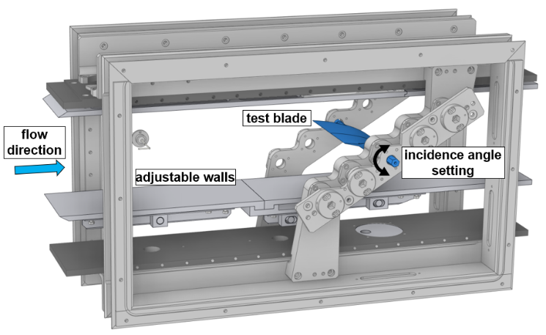
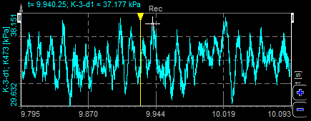
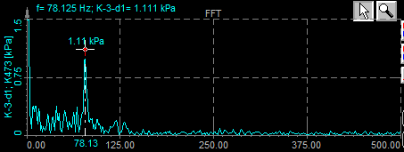
Figure 1. Test section with the compressor blade (left). Signal from the Kulite pressure transducer on the suction side of the blade in time and frequency domain for the case $M=0.39, θ=33^{∘}$ (right).

References
Kielb, R.E., Barter, J.W., Thomas, J.P., Hall, K.C., 2003. Blade Excitation by Aerodynamic Instabilities: A Compressor Blade Study, in: GT2003. Volume 4: Turbo Expo 2003, pp. 399–406. https://doi.org/10.1115/GT2003-38634
Stapelfeldt, S., Brandstetter, C., 2020. Non-Synchronous Vibration in Axial Compressors: Lock-in Mechanism and Semi-Analytical Model. Journal of Sound and Vibration 488, 115649. https://doi.org/10.1016/j.jsv.2020.115649
Lepicovsky, J., Šimurda, D., Kielb, R.E., Šidlof, P., Štěpán, M., 2023. Quasi-Dynamic Approximation of Unsteady Pressure Distribution for Transonic Airfoils in Flutter. Journal of Turbomachinery 145. https://doi.org/10.1115/1.4062181
Schreiber, H.A. and Starken, H. (1984), Experimental Cascade Analysis of a Transonic Compressor Rotor Blade Section”, J.of Eng. for Gas and Power, 106, pp. 288-294.
Brandstetter, C., Stapelfeldt, S., 2022. Near-Stall Modelling of a Pitching Airfoil at High Incidence, Mach Number and Reduced Frequency. IJTPP 7, 26. https://doi.org/10.3390/ijtpp7040026

acknowledgements
The research was supported by project MŠMT Inter-Excellence LUAUS23231 Origins and mechanisms of flutter and non-synchronous vibration in modern turbomachines operating at wide range of regimes.

