experimental 1mw steam turbine in double-rotor configuration

Michal Hoznedl, Jindřich Bém, Tereza Kubíková
Doosan Škoda Power s.r.o., Czech Republic

Abstract
The article describes a test rig for the experimental verification of the superheated steam flow through the control and follow-up stage of an experimental steam turbine placed in Doosan Škoda Power laboratory. Due to the innovative solution concept, the turbine is equipped with two mechanically independent rotors and the possibility to measure the performance of the control and follow-up stage separately. In the case of the control stage, it is also possible to simulate the partial admission by covering part of the inlet cross-section and to determine the energy loss by the presence of partial admission. In a wide range of rotational speeds of one or both rotors and steam inlet and outlet pressures and steam inlet temperature, local values of efficiency, stage reactions, Mach and Reynolds numbers and losses in the inter-stage channel can be determined by measurement for both stages separately. It is possible to probe the flow fields along the blade length before and behind both stages. Experiments, including probing, can be carried out at a pressure of up to 4 bar(g) and a temperature of up to 300 °C. The obtained data are used for tuning and verification of 3D CFD simulations and for corrections of the in-house SW system for the design of flow paths.

introduction
The control stage of the steam turbine is one of the most important components of the machine. Its correct design largely determines the behavior of the entire turbine. For smaller output turbines (approx. < 50 MW), the control stage can generate up to 10 % of total output. At the same time, the control stage is fitted with nozzle blocks in order to regulate the turbine output by closing four control valves. The control stage is followed by an inter-stage channel to the subsequent reaction stage with already full admission. The channel must be as short as possible and with the lowest energy loss. Partial admission influences the flow in the transition channel as well as the overpressure stage. Examining only the control stage or only the reaction stage separately is not reasonable considering the complexity of the flow. In its current form, there is probably no similar facility on a global scale, but there is a steam turbine with an isolated last stage [1].
RESULTS and DISCUSSION
The scheme of the flow part is given in Figure 1. Along the turbine circumference, each measuring point is realized four times in order to capture the circumferential inequality of the steam flow. The course of efficiency, mainly of the reaction stage, in dependence on u/cis determined from enthalpies shows certain anomalies given by the position of the thermometers, which are in touch with steam flow only at certain circumferential velocities. The measured pressures and temperatures therefore do not provide the mean characteristic value of the quantity along the cross-section, but serve as local control points for extensive 3D numerical simulations.

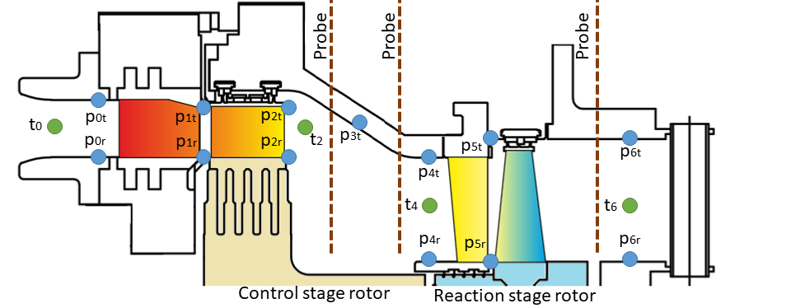
Figure 1. Positions of measuring points in the flow part
References
[1] Sigg R. et al.: Numerical and experimental investigation of a low-pressure steam turbine during windage, Part A: Journal of Power and Energy, 2009, 223(6), https://doi.org/10.1243/09576509JPE826

