COOLED FAST-RESPONSE STATIC PRESSURE PROBES FOR HARSH ENVIRONMENT APPLICATIONS

Julien Clinckemaillie  von Karman Institute for Fluid Dynamics | Fabrizio Fontaneto  von Karman Institute for Fluid Dynamics

Abstract
The present paper discusses the design methodology for a water-cooled fast-response wall-static pressure probe intended for measurements in the combustion chamber of gas turbines, as well as the results from a series of tests performed with the first prototype of the probe mounted in the primary zone of the combustion chamber of a turboshaft engine test rig.

introduction
In an effort to extend the knowledge around combustion instabilities while supporting the development of more performant combustion control systems, the availability of fast-response pressure measurement devices able to operate in the harsh environment of gas turbine combustors is fundamental. The severe heat load at which they are submitted forces the adoption of a cooling layout in order to keep the probe material well below its maximum operating temperature. This constraint becomes even more critical when the fragile sensing element of conventional off-the-shelf piezo-resistive fast-response pressure transducers is considered.

RESULTS and DISCUSSION
The first part of the present paper reviews the design methodology of a water-cooled fast-response wall static pressure probe intended for measurements of combustion instabilities in gas turbine combustors, describing the optimization of measurement performance in terms of frequency bandwidth ([0 – 40kHz]) as well as the design of the cooling layout ensuring the sensor’s integrity within a harsh environment (P = [5 – 15] bar and T = [1300 – 1900] K]). From very basic data inputs (i.e. pressure, temperature, and rough dimensions of the combustor), the heat load at which the probe will be submitted is obtained through reduced order correlations. This boundary condition is then used on an empirical correlation-based quasi-2D conjugate heat transfer model as well as on fully 3D RANS-based conjugate heat transfer numerical simulations, validating the design of the cooling layout for effective sensor cooling.

The second part of the paper focuses on the analysis of the results obtained from trial tests performed using the first probe prototype mounted in the primary zone of the combustion chamber of a helicopter engine test rig. The cooled probe prototype survived for 32 minutes of effective testing time and 4 engine starts, exhibiting a maximum cooled sensor membrane temperature of 350 K and delivering meaningful mean and fluctuating wall static pressure measurements (Figure 1). A critical sensor failure prevented further measurements, with the root cause of the failure tracing back to excessive soot contamination on the sensing element.

Finally, the strengths and strong potential for further growth of the current probe design are highlighted, while its shortcomings and (short-term) solutions to these shortcomings are also discussed.

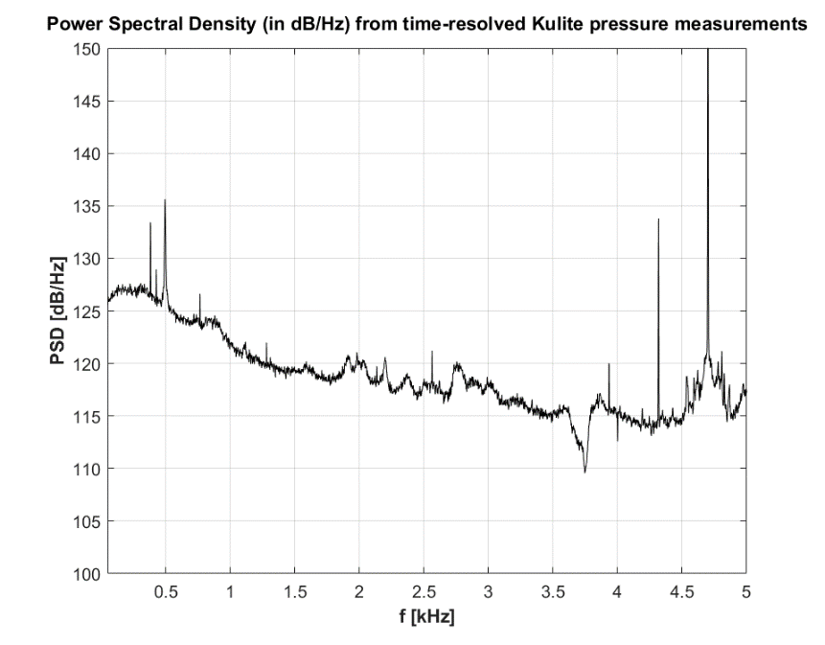
Figure 1. Power Spectral Density (in dB/Hz) from time-resolved Kulite static pressure measurements in primary zone of a turboshaft combustion chamber (idle conditions)

