Time of Flight estimation in acustic pyrometry: sensitivity to pulse characteristics

Lorenzo Ferrari  University of Pisa (DESTeC)  Largo Lucio Lazzarino, 1  56122 – Pisa – Italy  lorenzo.ferrari@unipi.it | Matteo Pettinari  University of Pisa (DESTeC)  Largo Lucio Lazzarino, 1  56122 – Pisa – Italy  matteo.pettinari@phd.unipi.it

Abstract
Acoustic pyrometry is a non-intrusive measurement technique that may find several applications in turbomachinery. This methodology is based on estimating the temperature by measuring the time of flight of an acoustic wave moving through a medium. This can be done by placing a sound source (emitter) and a receiver or microphone on opposite sides of a section. The transmitter emits a pulse of sound, and the receiver detects it. Because the distance between the emitter-receiver couple is known and fixed, the average temperature of the path traversed by the acoustic pulse can be computed. The time of flight can be determined from the cross correlation of the signals generated and captured by the emitter-receiver couple. When propagating within a medium, an acoustic wave suffers from attenuation of its power spectrum due to energy losses. Hence, for a fixed distance between the emitter and the receiver, or when high-frequency waves are considered, the time of flight estimation becomes more and more critical. It is then crucial to select proper acoustic waves to maximize the detection between the signals captured by the two microphones, thus improving the accuracy of the time of flight measurement and, consequently, the estimation of the temperature map. In this study, the authors investigated the impact of different acoustic waves on the accuracy of the measurement. Several acoustic signals were considered for the emitter. For each test signal, a corresponding one was synthesized for the receiver, accounting for noise corruption of the instrumentation and atmospheric attenuation. The cross correlation between each pair of signals was then performed. Finally, the time of flight estimation was compared with its actual value, thus providing insights into the most suitable choice of the acoustic wave for acoustic pyrometry applications. Hence, this study represents a first stage given the setup of an experimental system for temperature estimation based on an acoustic pyrometer.
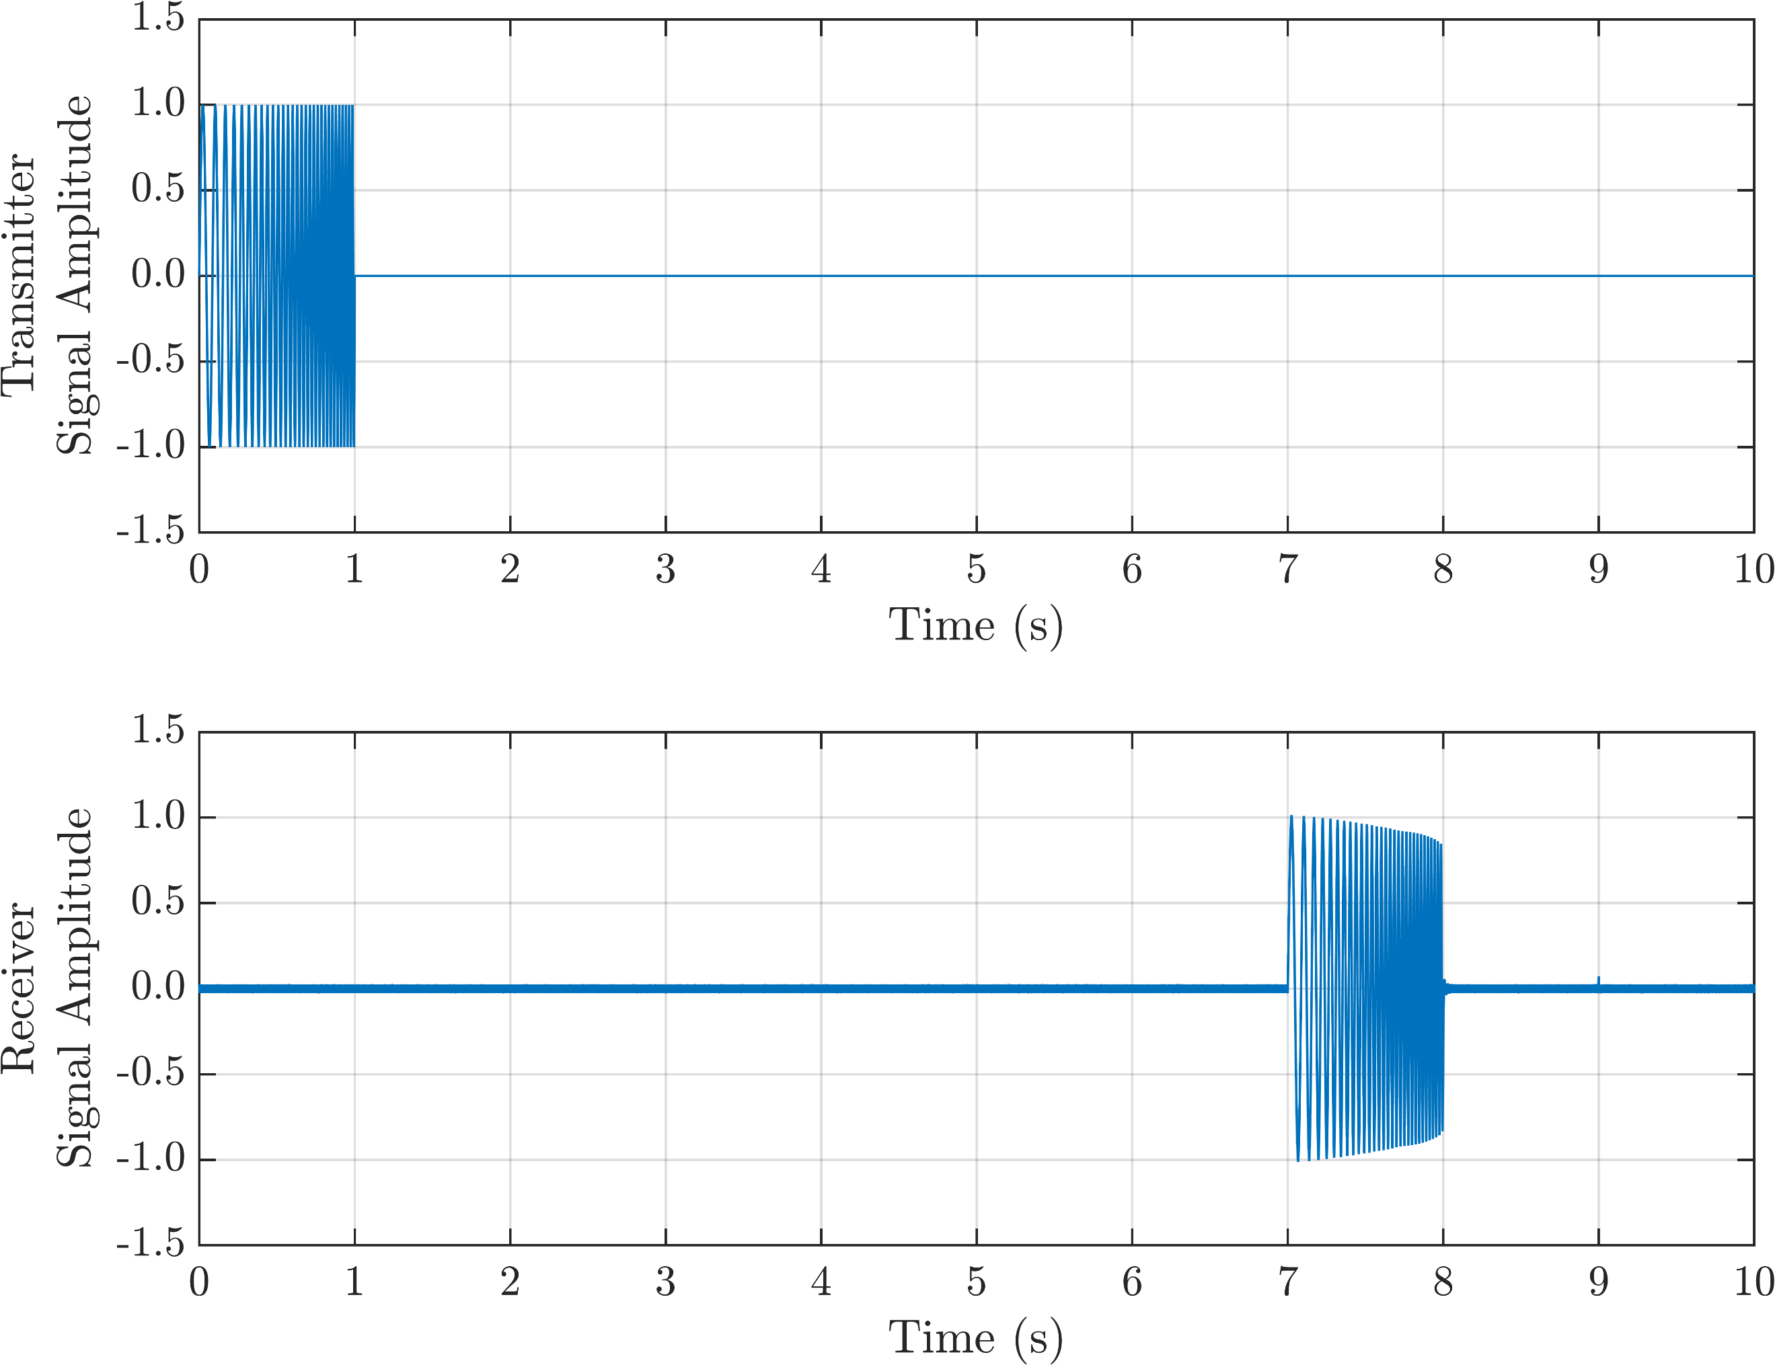
Figure 1: Actual and perturbed chirp signal for a transmitter-receiver couple

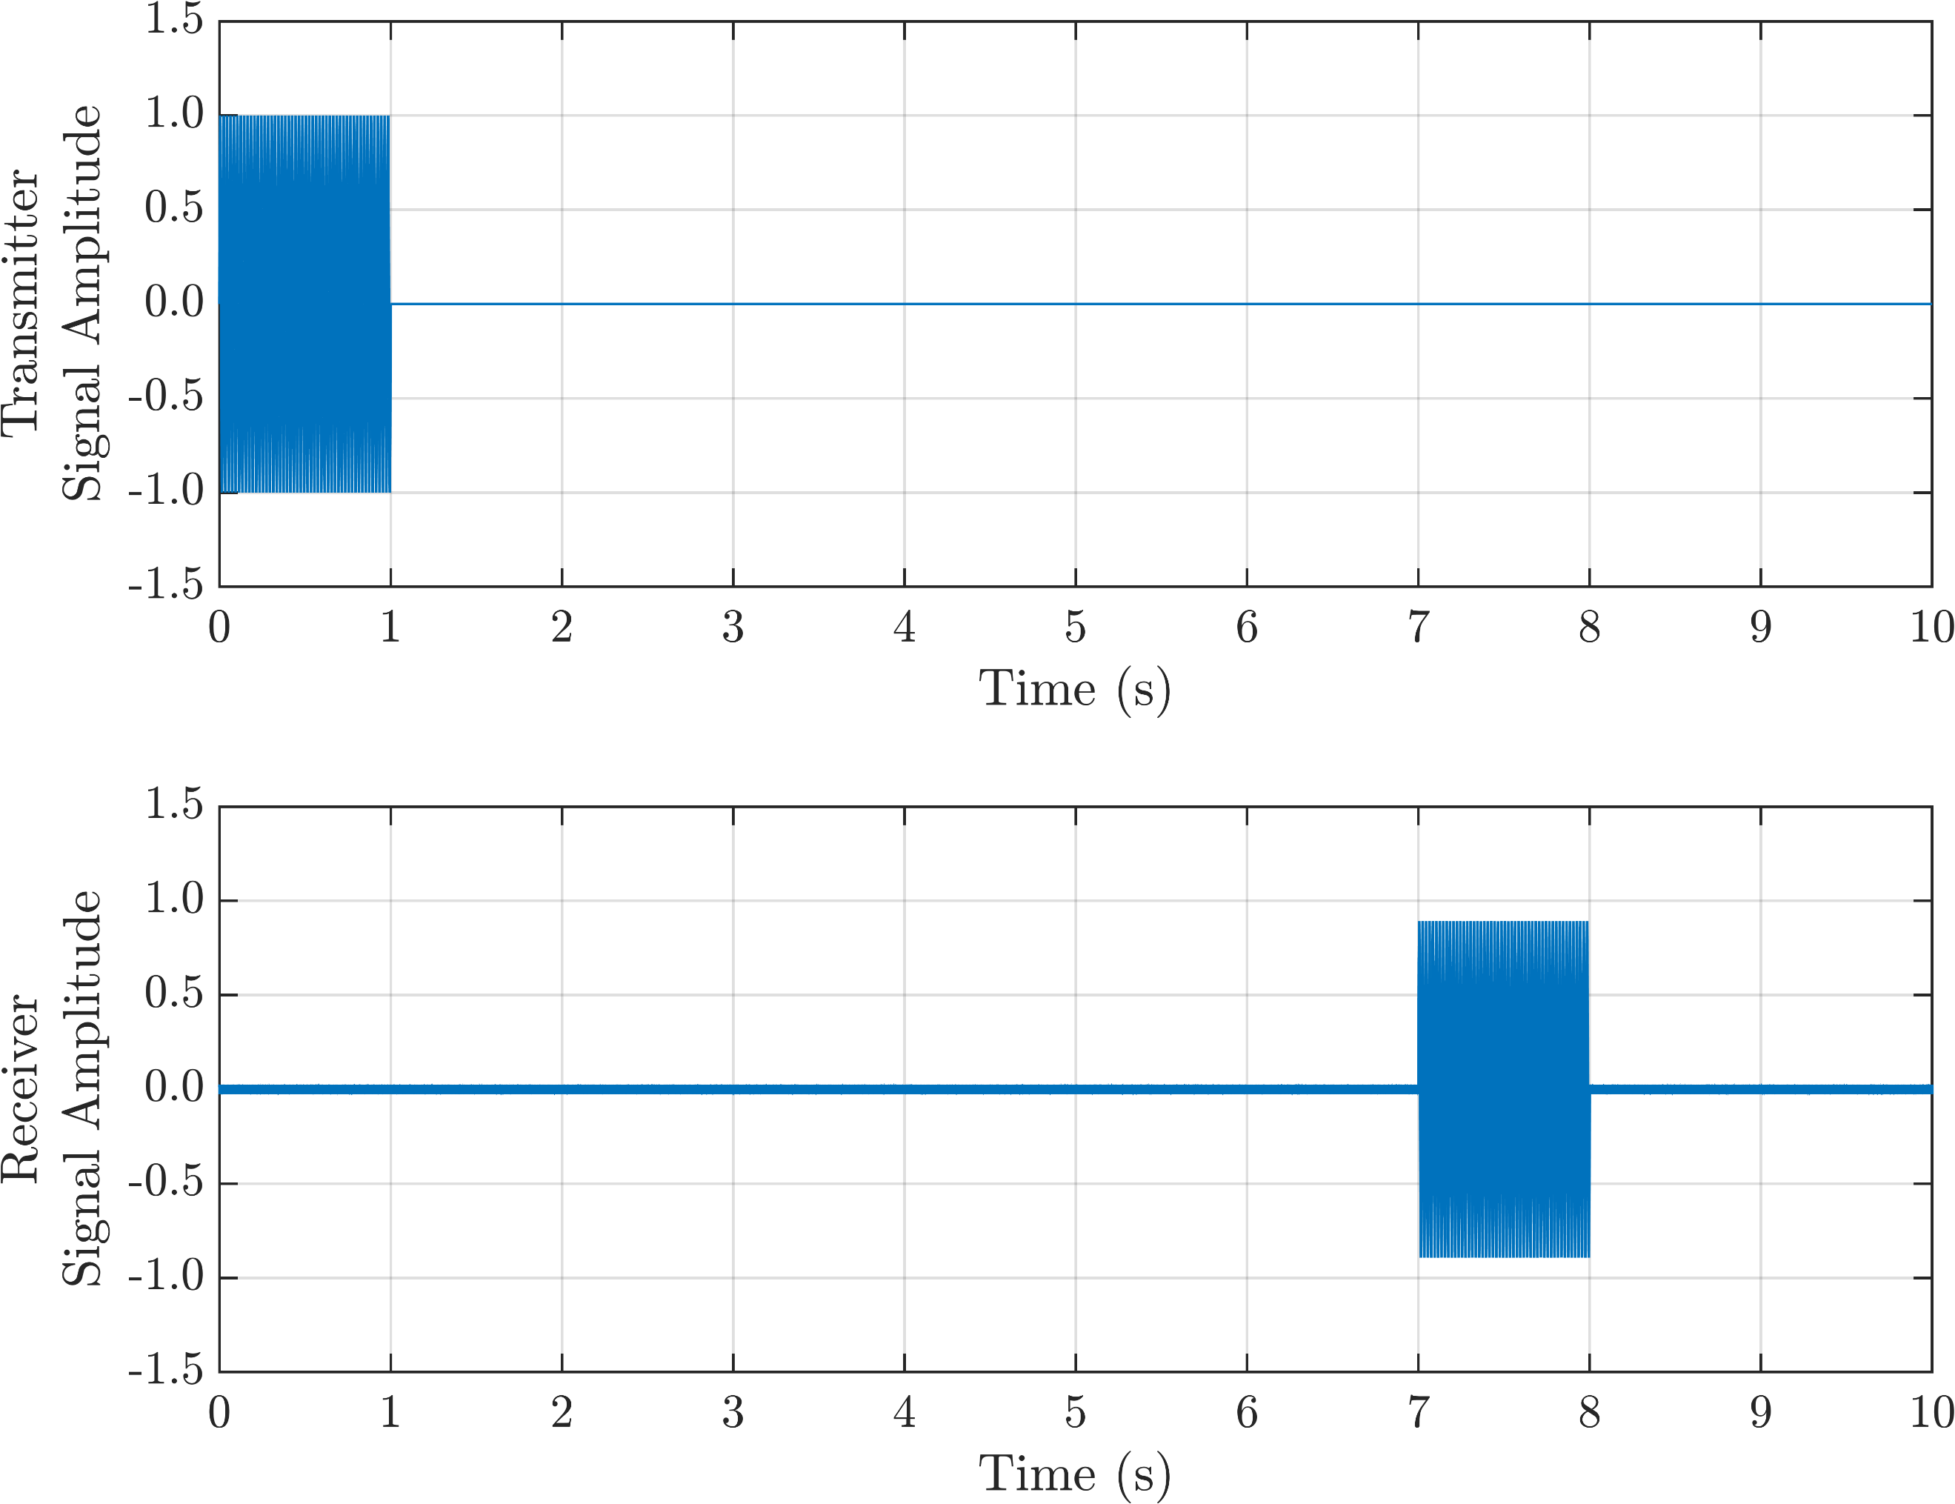
Figure 2: Actual and perturbed pure tone signal for a transmitter-receiver couple

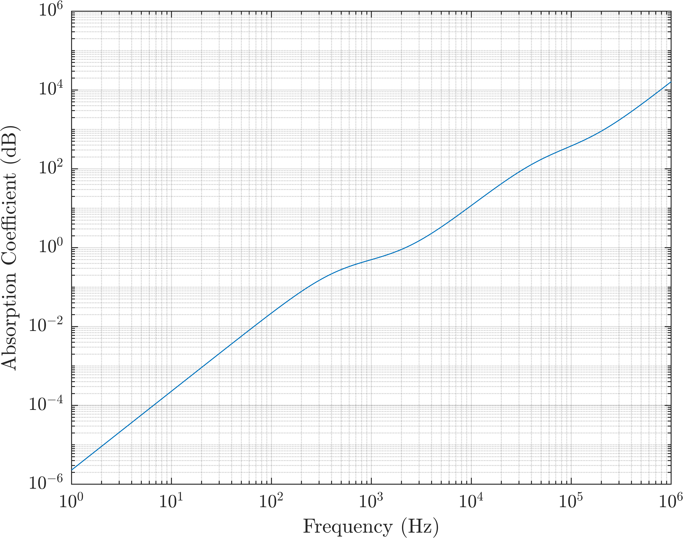
Figure 3: Atmospheric absorption due to the vibrational relaxation times of oxygen and nitrogen. (T = 20°C; p = 1 atm; d = 100 m; RH = 70%)

