investigation of the Supersonic flow past a wedge-shaped geometry using Pressure sensitive paints technique

Jindřich Hála, David Šimurda, Jan Lepičovský, Martin Luxa
Institute of Thermomechanics of the Czech Academy of Sciences, Prague, Czech Republic

Abstract
This study aims to present results of an investigation of the supersonic flow past a wedge-shaped geometry using the pressure sensitive paints technique (PSP). The wedge-shaped geometry was chosen as a canonical case for the investigation of the supersonic flow involving shock waves and expansion and thus convenient to build a first practical experience with this technique, further intended for use in the investigation of linear blade cascades in high speed laboratory of the Institute of Thermomechanics of the Academy of Sciences of the Czech Republic. The tests on the wedge-shaped geometry were complemented with the numerical simulations and static pressure taps measurements. The resulting static pressure distribution obtained using the PSP on the wedge-shaped test article revealed all main flow structures including positions of the separation and reattachment shocks providing a good picture of the whole flow field.

introduction
Three dimensional effects are of significant concern in linear blade cascades research as the corner flow structures significantly affect the axial density velocity ratio (AVDR) [1][2], an important parameter in compressor cascades investigation. Suction slots or perforated walls can be used to control the corner flow structures and thus the AVDR. From the practical point of view, it is convenient to have a technique capable of exposing the extent of three dimensional effects during the course of measuring campaign to allow for adequate setting of the suction. The pressure sensitive paints technique (PSP) seems to offer this and at the same time provide valuable data on the flow structures on the surface being investigated.
The present investigation was performed for an inlet Mach number of 1.9 and the wedge-shaped test article was instrumented with multiple pressure taps to provide the static pressure data for an in-situ calibration of the PSP according to [3]. The resulting static pressure distribution well corresponds with the numerical simulations and capture the main flow features. The paper includes detailed description of the flow field and its comparison with the numerical simulation.

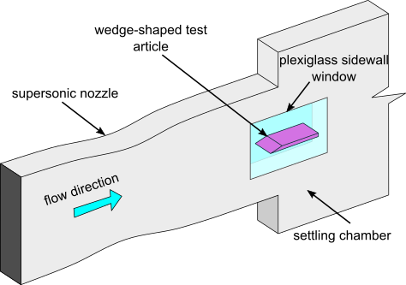  a) | 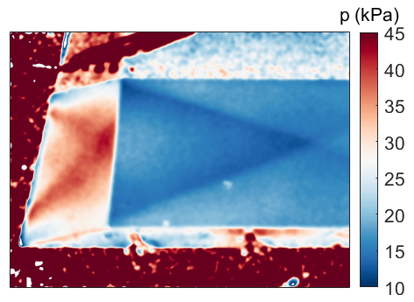  b)
Figure 1. a) Schematic depiction of the test section with the wedge-shaped test article inside b) Static pressure distribution over the test article obtained using the PSP (M₁ = 1.9).

References
- Song, B., Ng, W. F., (2007). The role of AVDR in linear cascade testing. Hangkong Dongli Xuebao/Journal of Aerospace Power. 22. 933-944.
- Choi J., Simurda D., Song J., Luxa M., Lee S., Hala J., Lepicovsky J., Radnic T., Seo J. Development of loss correlation and tool validation at transonic condition based on cascade test, (2021), DOI: 10.1115/GT2021-01771.
- Liu T, Sullivan JP (2005) Pressure and temperature sensitive paints. Springer, Berlin. https://doi.org/10.1007/b137841. ISBN 978-3-540-26644-0

