test RIG design considerations to DETECT volatile organic compounds in aircraft cabins

Christos P. Nasoulis, Stavroula Mantziou, Vasilis G. Gkoutzamanis, Anestis I. Kalfas
Laboratory of Fluid Mechanics and Turbomachinery
Department of Mechanical Engineering
Aristotle University of Thessaloniki
GR-54124, Thessaloniki, Greece

Abstract
This work presents a numerical investigation targeting to simulate the aircraft cabin as an environmental chamber and assist in the design of a test rig assimilating passenger comfort, when exposed to odor effects and high Volatile Organic Compound (VOC) concentrations. This study aims to evaluate particle dispersion with the use of Computational Fluid Dynamics (CFD), to determine the mass flow and particle residence variation effects as a function of a passenger’s position (i.e., olfactory system relation) and finally, to decide inlet characteristics as well as sensor locations to quantify passenger’s comfort. The results provide the flow field characteristics inside the aircraft’s cabin, as well as the species’ concentrations and residence time, all of which will act as input for the design of a test rig to evaluate the comfort of specialized groups such as aviation professionals and frequent travelers. The test rig will be designed to accommodate olfactometers and Electroencephalographic measurements, through an interdisciplinary, biomedical engineering perspective.

introduction
Aviation Medicine combines aspects of preventive and environmental medicine to improve the physiology and psychology of human in flight. Additionally, in-cabin odors have long been an operational challenge for airlines. On one hand, passengers claim that eating experience during flight may be dissatisfactory. Additionally, unwanted fumes may be introduced through the aircraft’s environmental control system (i.e., bleed air), thus contributing to the cabin’s air contamination.
In order to understand particle diffusion, a transient aircraft cabin simulation is set, to act as an air chamber that uses mass transfer of particles to capture the sense of odor, taking advantage of ventilation system. In this way, computational fluid dynamics (CFD) is used as a modern tool to find particle diffusion composed of volatile organic matter (VOCs). The volatile organic compounds used are tetrachloroethylene, hexadecane, naphthalene, and styrene, that are associated with the diffusion of fuel into the aircraft cabin and are considered hazardous to health.
RESULTS and DISCUSSION
Results indicate the effects of mass flow and VOC concentration on the overall VOC residence time inside the aircraft’s cabin. Additionally, computational data is used to train a model that will act as a digital nose, able to predict the fractions of various compounds, such as VOCs, inside the cabin and define the limits beyond which, the concentrations of each compound may become effective for the passengers. As an example, a feature selection-based Boruta algorithm is used, based on VOC mass, sensor location, air mass and time.

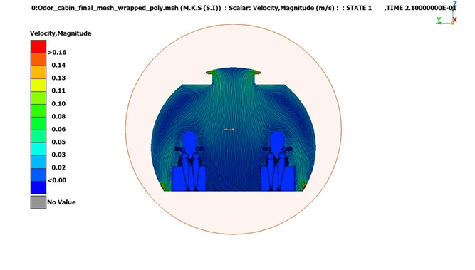

Figure 1. Velocity flow field inside the aircraft cabin

References
- Yin Y, He J., Zhao L., et al., (2022), Identification of key volatile organic compounds in aircraft cabins and associated inhalation health risks, Environmental International, 158, doi: 0.1016/j.envint.2021.106999.
- Schuchardt S., Koch W., and Rosenberger W., (2019), Cabin air quality – Quantitative comparison of volatile air contaminants at different flight phases during 177 commercial flights, Building and Environment, 148, pp. 498-507, doi: 10.1016/j.buildenv.2018.11.028.
- Zhang T., Chen Q. Y., and Lin C-H., Optimal Sensor Placement for Airborne Contaminant Detection in an Aircraft Cabin, 13:5, pp. 683-696, doi: 10.1080/10789669.2007.10390980.
- Doty R., The olfactory system and its disorders, Semin Neurol. 2009 Feb;29(1):74-81. doi: 10.1055/s-0028-1124025.

