A new experimental test rig for performance analysis of radial compressors inside innovative heat pumps

Marco Ferrando ª, Tommaso Reboli ª, Alberto Traverso ª | ªUniversity of Genoa

Abstract
Electrification is playing a major role in the industrial and energy sector, with heat pump (HP) market expected to grow significantly in the next future in accordance with the current energy transition phase, which aims to reduce the utilization of fossil fuels for heat production sector. It is therefore of crucial importance to find new ways to increase heat pump performance and reliability, containing maintenance costs. The use of dynamic compressors in HPs makes it possible to combine good performance with high compactness and silent operation, but unlike the volumetric compressor, this equipment could undergo dangerous instability during operation. The aim of this paper is to present a new test-rig for stable and unstable performance analysis of dynamic compressors for innovative heat pumps. An in-depth description of the plant and sensor system is provided. The performance of the compressor and of the whole cycle are analyzed for different operating points, with a particular focus on near surge operation. Experimental uncertainties and their reduction through data reconciliation techniques is thoroughly investigated.

introduction
The test rig presented in this paper is the result of a collaboration between the University of Genoa and Carrier Corporation, the objective of which is to analyze the performance of dynamic compressors in stable conditions and in surge conditions within innovative heat pump cycles. The experimental setup allows to vary the operating conditions of the heat pump, and thus the compressor pressure ratio with great flexibility. It turns out to be possible to manipulate the Heat Transfer Fluid (HTF) temperatures and flow rates at both the condenser and evaporator sides, allowing to evaluate the performance in different environmental conditions. Figure 1 shows the P&ID of the experimental test rig. In this figure the HTF lines are in light blue while the refrigerant lines are in green and orange.
RESULTS and DISCUSSION
A detailed analysis of the experimental setup is carried out, highlighting construction choices that provide high operational flexibility. Critical issues encountered and possible solutions to reduce them are shown. Some stable operating conditions at different compressor speeds are shown in order to demonstrate the capability of the experimental set-up. Stable points were characterized with improved accuracy, using data reconciliation techniques to reduce instrumental uncertainties.
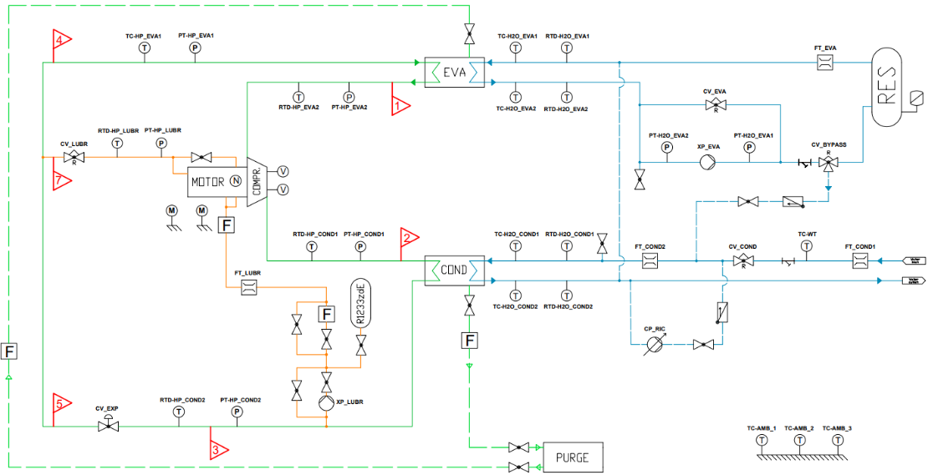

Figure 1. P&ID of the experimental test rig

