Experimental monitoring of vibrations and the problem of amplitude quantification

Alexandra P. Schneider*
Benoit Paoletti
Xavier Ottavy
Christoph Brandstetter
Université de Lyon, Ecole Centrale de Lyon, CNRS, LMFA, UMR 5509, F-69134, ECULLY, France

Abstract
Today, experimental monitoring of blade vibration in turbomachinery is based on blade-mounted strain gauges. Their signals are used to derive vibration amplitudes which are compared to previously determined modal scope limits typically including a safety factor. According to industrial guidelines this factor is of conservative nature to ensure safe operation of the machine.
In order to conduct measurements close to the stability limit like within the planned measurement campaign with the fan ECL5, which is representative for modern lightweight UHBR fan, it is necessary to minimize this safety factor. At the same time, it is mandatory to use monitoring methods which do not result in underestimation of measured vibrational amplitudes. In a previous study, Brandstetter et al. [1] showed that spectral amplitudes of a fast response wall pressure transducer depend on selected FFT parameters.
To study the impact of the spectral method on amplitude estimation, this study presents a systematic analysis of involved parameters. This allows to improve the robustness of utilized analysis methods and enables safer monitoring of the test facility.

introduction
Within the European project CATANA the open test case fan ECL5 will be used to perform experiments near the stability limit to investigate aeroelastic phenomena. In modern fan architectures, these phenomena lead to rapidly rising blade vibration and thus, operation close to those regions is extremely critical.
Established test procedures are based on industrial guidelines resulting in conservative security limits, which ensure the structural integrity during operation. Therefore, they prevent stabilizing the machine at operating conditions near the safety-critical range. However, this is necessary to study the evolution of vibration amplitudes and underlying physical mechanisms. Accordingly, these procedures are not suitable for the planned measurements.
Experimental surveillance of blade vibration is based on FFT calculation to provide the amplitude for each vibrational frequency, which can be compared to modal scope limits for different eigenmodes. For ECL5 experiments, it is necessary to minimize the mentioned safety factor while ensuring that calculated spectral amplitudes are independent from chosen method parameters in order to guarantee correct assessment of blade stresses.
In their study, Brandstetter et al. [1] observed that spectral amplitude decreases up to 50% if the window size is increased from 5 to 25 rotor revolutions. In the case of measurement surveillance by means of strain gauges such a dependency can result in a safety-critical underestimation of vibration levels. To avoid this, it is necessary to understand the relation between method parameters and calculated spectral amplitude.
RESULTS and DISCUSSION
The presented parameter study aims to improve the robustness of utilized analysis methods to enable safer monitoring of the test facility. This allows to operate the machine closer to the stability limit and thus, enables detailed investigation of safety-critical phenomena.
The test case used within this study is the ENOVAL fan geometry, which is comparable to ECL5. The extensively instrumented test facility ECL-B3 at Ecole Centrale de Lyon allows to study the influence of various parameters such as FFT window size, rotational speed and vibrational eigenfrequency.
Amongst other parameters which will be discussed in detail in the paper, the window size used for FFT calculation has a major impact on spectral amplitudes as shown in Brandstetter et al. [1] (see Fig. 1).

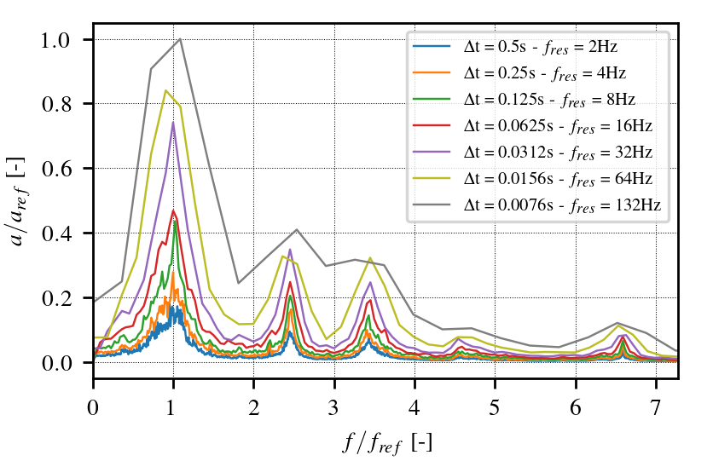

Figure 1. Spectrum of blade-mounted strain gauge for different FFT window size at design speed

Systematic variation of mentioned quantities offers the possibility to generalize method parameters which allows the application to different experimental configurations.

References
- Brandstetter, C., Ottavy, X., Paoletti, B., and Stapelfeldt, S., 2021. “Interpretation of stall precursor signatures”. Journal of Turbomachinery, 143(12), p. 121011

