Fluorescent PIV Technique for Turbomachinery Flows

M. Okada, J. Pinho, S. Lavagnoli
Turbomachinery and Propulsion Department, von Karman Institute for Fluid Dynamics, Belgium

Abstract
One of the major sources of concern for experimentalists employing Particle Image Velocimetry (PIV) is undesired strong light reflections on surfaces of channel walls or obstacles. The issue is emphasized in applications composed of complex geometries with highly reflective surfaces such as turbomachinery rigs. This paper presents a development and applications of a fluorescent PIV technique as a countermeasure for such a problem. An employment of fluorescent dye-doped tracer particles with a wavelength-specific optical filter enables separation of the stokes-shifted particles light emission from reflections on surfaces.
Aiming at applying the technique into engine-like turbomachinery flows, we have made fluorescent tracer particles out of pyrromethene 567 and Di-Ethyl-Hexyl-Sebacat considering multiple aspects of characteristics.
Three application cases are reported in this paper, firstly the developed particles were tested in a low-speed wind tunnel with a metal turbine blade placed in the flow path and laser sheet oriented to impinge the blade surface. With the installation of an adequate optical filter, the undesired light reflections were successfully removed, and reasonable vector calculations were enabled in proximity to the reflective blade surfaces. Secondly, the fluorescent PIV performed on high pressure turbine stage hosted in a high-speed short-duration rotating turbine rig demonstrated feasibility of the technique in engine representative turbomachinery flows. Lastly, a design of fluorescent PIV experiments on a high-speed low pressure turbine cascade rig is introduced as a future work.

introduction
Particle Image Velocimetry (PIV) is a powerful measurement tool that can obtain instantaneous spatial flow data. However, in some cases such as turbomachinery test rigs which inherently contains reflective surfaces with complex geometries, undesired reflections on surfaces troubles experimentalists deeply because vector calculations cannot be performed when particle images are overwhelmed by reflections. Furthermore, incidence of excessively strong light into image sensor can cause permanent damages in pixels. To overcome such challenge, the use of fluorescence dye-doped particles and optical filter was investigated to separate fluorescent emission of particle from reflections .
For particle base, Di-Ethyl-Hexyl-Sebacat (DEHS) was selected as it has been widely used for gas flow and it is compatible with Laskin nozzle particle generators which can produce large amount of submicron droplets. Besides, it has higher boiling point compared to other candidates such as methanol or olive oil. Pyrromethene 567 (P567) was selected for fluorescent dye considering its high fluorescent emission efficiency at 527 nm wavelength excitation and solubility in DEHS. In addition, it must be noted that toxicity of materials is also an important aspect to be concerned as gas is inherently more difficult to contain in designated space than liquid. P567 is a toxic substance, yet the hazardous level is in general lower compared to commonly used Rhodamine 6G or Rhodamine B according to the hazardousness classification from regulation (EC) No 1272/2008.
RESULTS and DISCUSSION
A set of PIV experiments examining a flow over a titanium alloy turbine blade placed in a low-speed wind tunnel was performed to demonstrate the potential effectiveness of the fluorescent particle in turbomachinery applications. Fig.1 presents instantaneous particle images overlapped by vector fields obtained using cross-correlation algorithm together with zoomed views and correlation maps. The left figure shows the results from Mie scattering image whereas the right figure shows fluorescent emission image.
The strong light reflection on the blade suction surface as well as the blade hub endwall illuminated by diffusion reflection appear in Mie scattering image. Close to the blade surface, the correlation map is strongly affected by those reflections, thus the vector estimation at such location is questionable. In fluorescent PIV case, thanks to the successful suppression of reflections, a distinctive peak can be found in the correlation map and the vector field shows a small vortex resolved near the wall with reasonable continuity along surroundings.

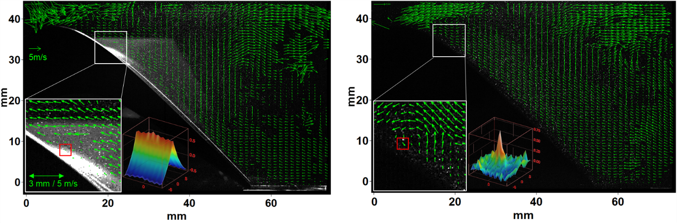
Figure 1. Instantaneous particle images and vector fields with zoomed views and correlation maps of the interrogation windows indicated by red rectangles. Left: Mie scattering case. Right: fluorescent emission case.

References
None.

