Environmental-Friendly Fire Suppression System for Cargo using Innovative Green Technology

Diakostefanis, M. / Cranfield University  Dinesh. A./ Cranfield University | Sampath, S./Cranfield University  Xiong, Y./ Cranfield University

Abstract
Fire suppression and explosion protection have conventionally used halon as the extinguishing agent due to favourable properties like being electrically non-conductive, dissipate rapidly without residue, safe for limited human exposure, and are extremely efficient in extinguishing most types of fires. However, halon is accompanied by high levels of Ozone Depletion Potential (ODP) and Global Warming Potential (GWP). In 1994, the Montreal Protocol issued a ban on the production of substances that deplete the ozone to reduce the consumption of these substances. Current estimates are that global halon availability will deplete by the year 2035, hence replacement with an environmental friendly alternative agent is imperative.

introduction
The EFFICIENT project is part of the Clean Sky 2 initiative that has developed a potential fire suppression technology for eventual application in the cargo-cabin architecture of existing and next generation aircraft. The aim of the study is to investigate if compressed nitrogen satisfies the extinguishing criteria, as specified by the Federal Aviation Authority (FAA) Minimum Performance Standard (MPS) and to test a prototype version of the EFFICIENT Fire Knockdown System (EFKS), which is the system responsible for the initial tackling of the fire. Four test scenarios of Bulk-Load and Containerised-Load Fire Test, Surface Burning Test and Aerosol Can Explosion Test were replicated and conducted in the cargo test cell according to standards mentioned in the FAA standard.
RESULTS and DISCUSSION
A wide body aircraft cargo hull of a simulator has been constructed and equipped with the appropriate instrumentation systems. An array of thermocouples is installed to measure the peak temperature during the fire suppression and the temperature over time integral inside the simulator. Also a combination of steady state and dynamic pressure transducers, and oxygen analysers analysers were used to control the cargo hull simulator environment as required by the MPS [1]. Zirconium-oxide oxygen analysers are used to determine sufficient oxygen volume concentration reduction during the suppression. Cargo door leakage flow is simulated and the flowrate is measured through a custom designed orifice plate by measuring the static pressure drop across it. The experimental tests were successfully completed and all the pass criteria of the MPS were been met, with very good accuracy in measurements recording. Additionally, the surface burning fire scenario was investigated using the Fire Dynamics Simulator (FDS) and validated against the experimental results.

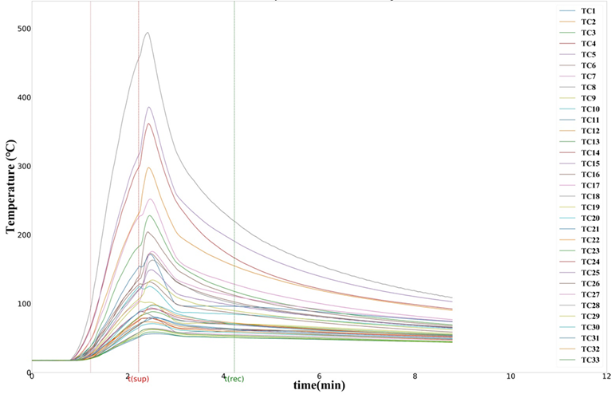

Figure 1. Measured Temperature Profile for Surface Burning Test Case

References
- Reinhardt, J. W. (2003) ‘Minimum Performance Standard for Aircraft Cargo Compartment Halon Replacement Fire Suppression Systems’, (April). Available at: http://www.fire.tc.faa.gov/pdf/TC-TN12-11.pdf.

