HIGH-accuracy INFRARED MEASUREMENTS IN THE OXFORD TURBINE RESEARCH FACILITY: CALIBRATION AND ERROR EVALUATION methods

Manuela Sisti Chiara Falsetti Kam S. Chana Paul F. Beard
Oxford Thermofluids Institute University of Oxford, Oxford, OX2 0ES. UK.

Abstract
This paper presents the calibration method and error evaluation for an infrared (IR) measurement system for the upgraded Oxford Turbine Research Facility (OTRF). The OTRF is a world leading turbine test facility capable of matching engine representative conditions of Reynolds and Mach numbers, non-dimensional speed and gas-to-wall temperature ratio.
Infrared measurements will provide temperatures on high-pressure (HP) turbine blades permitting full surface evaluation of metal effectiveness at engine representative conditions for the first time.
The test environment presents significant challenges for accurate IR thermography measurements. High temperature of neighboring components causes high reflected radiation to reach the IR detector offsetting the measurement, whilst high blade velocity (~200 ms⁻¹) challenges clear image acquisition.
Using a bespoke calibration facility, an IR thermography calibration procedure was assessed to evaluate the surface emissivity of the target, the transmissivity of the optical path, and the erroneous reflected radiation. Future steps will be developing a MATLAB model to de-blur the acquired images (S. L. Gazzini 2017). The results of this study will allow an advanced and highly accurate IR measurement system to be implemented in the upgraded OTRF.

introduction
A strive for high power and efficiency in jet engines causes turbine entry temperatures to increase. Thus, understanding the heat transfer phenomena and being able to predict the thermal performance of high-pressure turbine components is the key to develop advanced cooling technologies and increase components life.
Infrared thermography provides a high-resolution, non-intrusive measurement technique capable of assessing the two-dimensional temperature ﬁeld on high-velocity targets in both transient and steady measurements. However, several factors can affect the accuracy of the measurement, such as the emissivity of the target, the reflection of the surroundings, and the transmissivity of the optical path. To calculate and compensate for these contributions, depicted in Figure 1(a), advanced in-situ calibration techniques are recommended (C. Falsetti 2020).
RESULTS and DISCUSSION
Experiments were performed to evaluate directional emissivity, the surroundings reflection and the transmissivity of the window. The calibration rig, shown in Figure 1(b, c), was designed to replicate the OTRF test conditions. An aluminum 6082 T6 disc, with a diameter of 450 mm, rotates at 8000 rpm, i.e. with a tangential velocity of $\sim$180 ms⁻¹. A cylindrical enclosure housed the disc and a Zinc Selenide window was installed on the cover to gain optical access.
The air was heated with a hot air blower up to a temperature of 400 K. Stripes were painted on the disc with high emissivity paint ($ε\sim \text{0.96}$) to simulate the passing of rotor blades. The digital triggering of the IR camera (FLIR A6751 SLS) was provided via a NI data acquisition and an on-shaft encoder systems using the disc rotational speed and the blade passing frequency.
The calibration procedure involved experiments and modelling to evaluate blackbody and greybody parameters (Kirollos 2015), successively used to correct the IR camera measurements.
A MATLAB vector code was developed to calculate the viewing angles for the reflections correction, whilst the reflective marker arrays method (B. Kirollos 2017) was used to evaluate the directional emissivity.

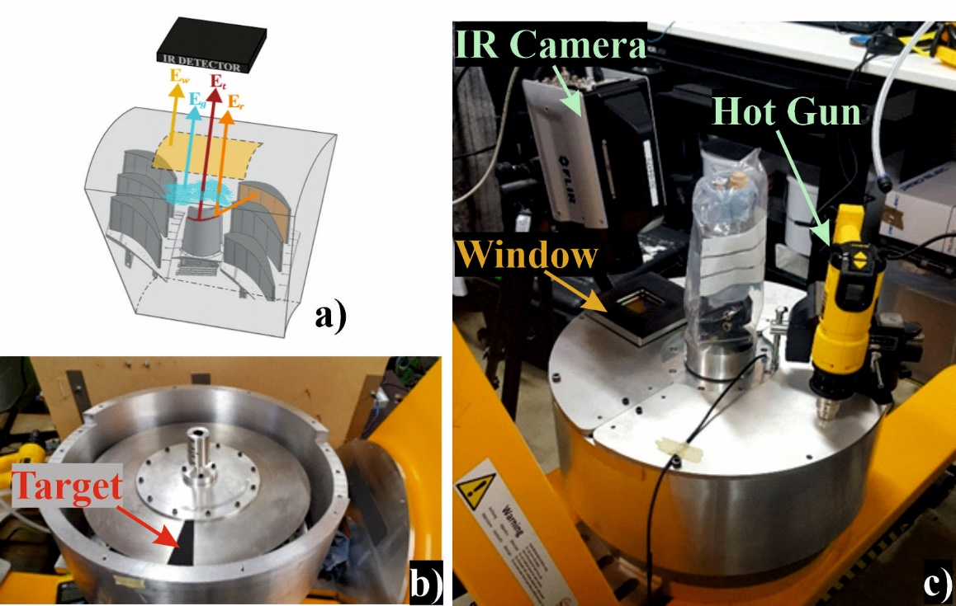
Figure 1 – a) IR camera measurements sources of error (C. Falsetti 2020): the signal reaching the camera detector is a sum of the radiation emitted by the target ($E_{t}$) and an offsetting radiation given by the surroundings, the window and the combustion gas ($E_{offset}=E_{r}+E_{w}+E_{g}$); b) Rotating disc painted with one stripe installed in the enclosure; c) Calibration Rig set-up.

References
B. Kirollos, T. Povey. 2017. “High-accuracy infrared thermography method using reﬂective marker arrays.” Meas. Sci. Technol. 28: 1-12.
C. Falsetti, M. Sisti, P. Beard. 2020. “Infrared Thermography and Calibration Techniques for Gas Turbine Applications: a Review.” Submitted (under review) Infrared Physics and Technology.
Kirollos, B. 2015. Aerothermal Optimisation of Novel Cooling Schemes for High Pressure Components using Combined Theoretical, Numerical and Experimental Techniques. PhD Thesis, Oxford: University of Oxford.
S. L. Gazzini, R. Schader, A. Kalfas, R. Abhari. 2017. “Infrared thermography with non-uniform heat ﬂux boundary conditions on the rotor endwall of an axial turbine.” Meas. Sci. Technol. 280: 1-16.

