Upgrade of the HIgh-Speed Cascade wind tunnel
at the bundeswehr University munich
Reinhard Niehuis, Martin Bitter
Institute of Jet Propulsion
Bundeswehr University Munich
reinhard.niehuis@unibw.de
Neubiberg, Germany

Abstract

The high-speed cascade wind tunnel (HGK) of the Bundeswehr University Munich is a well-known test facility in the turbomachinery community. Due to its ability to change two similarity parameters, namely Mach and Reynolds number, independently from each other at engine relevant conditions, it is a unique test facility worldwide, whose performance map is very well suited for research on airfoil aerothermodynamics. Originally erected at DFL (today DLR, the German Aerospace Center) Braunschweig by late Professor Schlichting and Professor Scholz it became operational in November 1956 [1], [2]. The facility’s large test section dimensions of up to 500^{H} x 300^{W} mm² enable very detailed experimental performance characterizations on numerous compressor and turbine airfoil generations which finally made it into service, both in flying and stationary turbomachinery. In 1984, the entire test facility was moved from Braunschweig to the Bundeswehr University Munich under the direction of late Professor Fottner [3], where it got operational on November 25, 1985 after an overhaul of the main components and a replacement of the pressure vessel by a one of significantly bigger volume. Since that time, the test facility has provided very valuable contributions to the field of turbomachinery research as it was heavily used by industry partners and for many different public funded, more basic research oriented projects.

Since there is still a high demand on cascade testing under engine relevant test conditions from industry, which, more than ever, seeks for highly efficient airfoils especially in the framework of “Flightpath 2050”, [4] it was decided to carry out a major revision of the test facility in order to ensure operational reliability and to upgrade the facility for future research requirements – more than 60 years after its first run and thousands of hours of intensive testing. In particular, the main components, i.e. the drivetrain, the compressor, and the main cooler date back to when the test facility got into service in 1956. During the main revision performed in 2017/2018 these components were replaced by new ones of the latest technology. Details on the new components will be comprehensively outlined in the paper. The new components now feature a higher power level allowing to extend the operating range of the test facility significantly. Parallel to this, a high level of automation was introduced to the facility. Together with a state-of-the-art real-time data acquisition system, the wind tunnel operation and surveillance finally again satisfy the raised demands on stability and measurement accuracy. The new features of the test facility and the extended operating range will be described in detail in the paper. The picture of the “new” HGK is rounded by the available portfolio on experimental techniques, both classical probe-based and non-intrusive techniques, which are also emphasized in the paper.

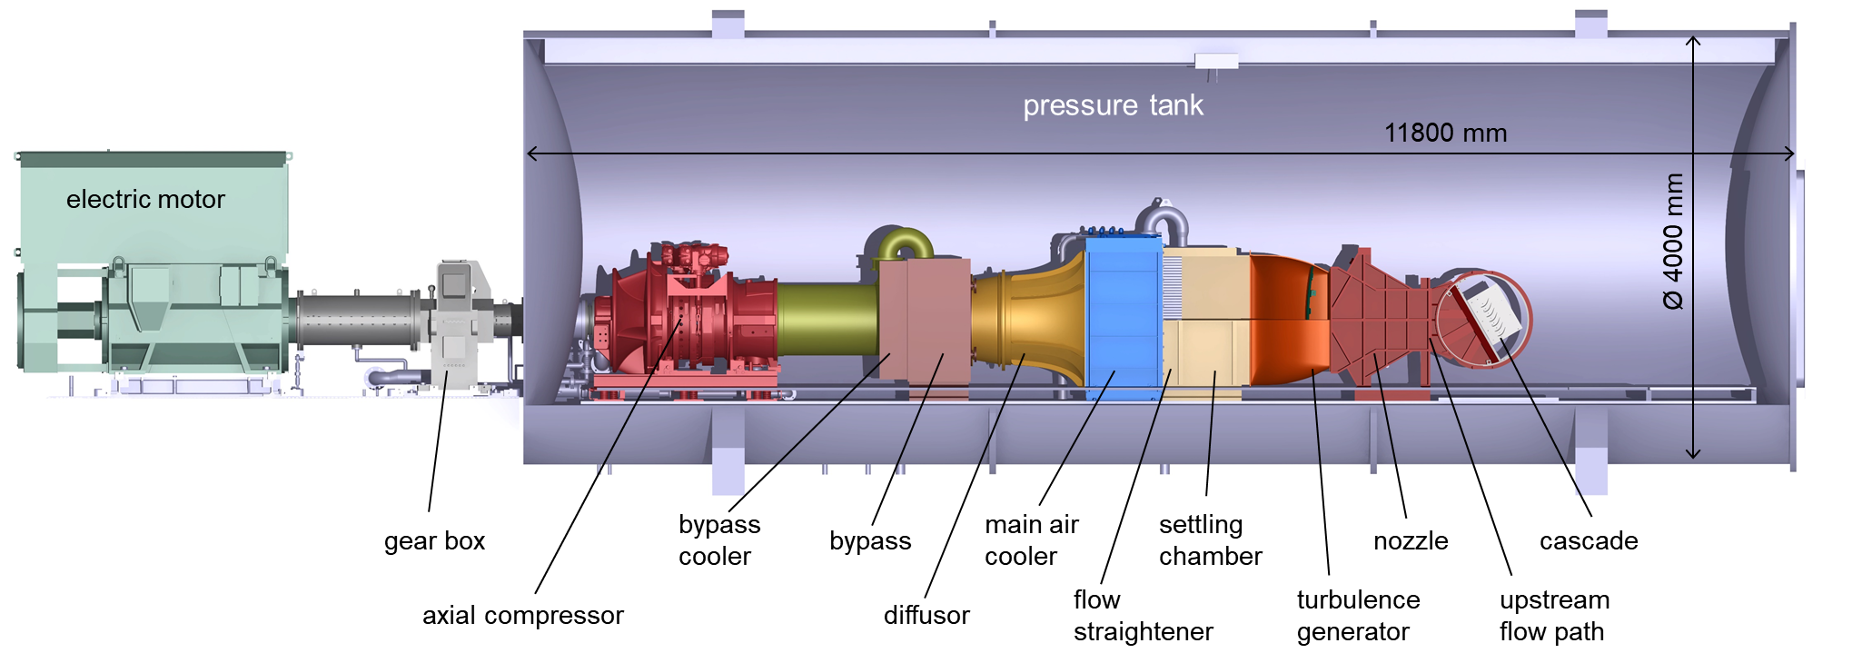

Figure 1. Schematic of the high-speed cascade wind tunnel
at Bundeswehr University Munich after major revision in 2017/2018.

REFERENCES
[1] Schlichting, H. (1956) The Variable Density High Speed Cascade Wind Tunnel of the Deutsche Forschungsanstalt für Luftfahrt Braunschweig. AGARD Report 91.
[2] Scholz, N., Hopkes, U. (1959) Der Hochgeschwindigkeits-Gitterwindkanal der Deutschen Forschungsanstalt für Luftfahrt Braunschweig. Forsch.Ing.-Wes. 25 (1959), Nr. 5, pp 133-147.
[3] Sturm, W., Fottner, L. (1985) The High-Speed Cascade Wind Tunnel of the German Armed Forces University Munich. 8th Symposium on Measuring Techniques for Transonic and Supersonic Flows in Cascades an Turbomachines, Genoa, Italy.
[4] European Commission (2011) Flightpath 2050 Europe’s Vision for Aviation, Report of the High Level Group on Aviation Research. DOI: 10.2777/50266.

