INterpretation OF Stall Precursor SiGnatures

Christoph Brandstetter  Xavier Ottavy  Ecole Centrale de Lyon, Laboratoire de Mecanique des Fluides et d’Acoustique, Lyon, France | Sina Stapelfeldt  Imperial College, Department of Mechanical Engineering, London, United Kingdom

Abstract
A very specific phenomenon which has been observed in many experimental studies on turbomachinery compressors and fans has been discussed under the term “rotating instabilities”. It is associated to a local aerodynamic phenomenon, typically occurring in the tip region at highly loaded conditions and often linked to blade vibrations. Even though the effect has been discussed over more than two decades, a very ambiguous interpretation still prevails. A particular problem is that specific signatures in measurement data are often considered to characterize the phenomenon despite possible misinterpretations. The present paper illustrates that a specific image of a pulsating disturbance that has been established in the 1990s needs to be reconsidered. At the example of a recent investigation on a composite fan the difficulties concerning sensor placement and post-processing techniques is discussed with a focus on spectral averaging, isolation of non-synchronous phenomena and multi-sensor cross-correlation methods.

introduction
Particular types of compressors develop aerodynamic disturbances in the tip region, which propagate around the circumference at stable operating conditions far from the onset of rotating stall. The disturbances are often inhomogeneous around the circumference and comprise a multitude of wavelengths. It has been observed in many experimental studies that the propagation speed of these disturbances is widely independent from the local wavelength and close to that of rotating stall precursors or cells. Measured from the stationary frame of reference, these phenomena occur as a range of frequency peaks at a fraction of the blade passing frequency, often referred to as a “broadband hump” in the pressure spectrum.
A typical spectrum, showing this type of disturbance has been published by Baumgartner (1995) [1], shown in fig.1. In this and further publications from the era the term “Rotating Instabilities” has been established. The spectrum shows not only a broadband disturbance (hump) around 30% of the BPF but also individual peaks with a narrow spacing. Also, this signature is modulated with the blade passing frequency and its harmonics, showing left and right-handed sidebands, indicating non-linear scattering. The source of the disturbance has been denoted as a form of vortex-shedding.
In [1] a link towards non-synchronous blade vibrations based on structural eigenmodes has been drawn. Based on the assumption that the spacing of the peaks in the spectrum corresponds to subsequent integer wave numbers, the frequency spacing between two peaks corresponds to the angular velocity of the respective disturbance. Since measured frequencies in the stationary and the rotating frame of reference could not directly be explained, the image of a rotating source-mechanism that can be considered a pulsating disturbance which propagates relative to the rotor has been established. Also, the image of a rotating loudspeaker was proposed and used to explain the coherence of the pressure disturbances with the structural vibration modes. This image was supported by the work of Kameier and Neise [2] who implemented a rotating loudspeaker into a fan-test rig and confirmed the theoretical assumptions concerning measured frequencies and compared them to experimental data from a fan which produced the so called RI spectra. It was furthermore observed, that within the relevant frequency range of the spectrum, a linear phase evolution is present in inter-spectra of circumferentially distributed sensors.
Numerous studies on the phenomenon have been conducted afterwards, partly leading to intense discussions on the semantics (“Rotating Instability” vs. “Part Span Stall” etc.) and the underlying aerodynamic effect (leading edge vortex separations, fluctuations of the tip leakage vortex).

In the paper we will show, that the image of a pulsating source mechanism is not necessary to explain the measured spectra but rather misleading. Instead, experiments indicate that widely stable disturbance patterns are convected at constant speed around the circumference.
Furthermore, the quantitative interpretation of frequency peaks in measured spectra is extremely sensitive. Physical interactions between structure vibrations, propagating acoustic modes and the convected aerodynamic disturbances can cause frequency lock-in and lead to erroneous interpretations. We will show how post-processing parameters and measurement methods have significant impact on the interpretation.

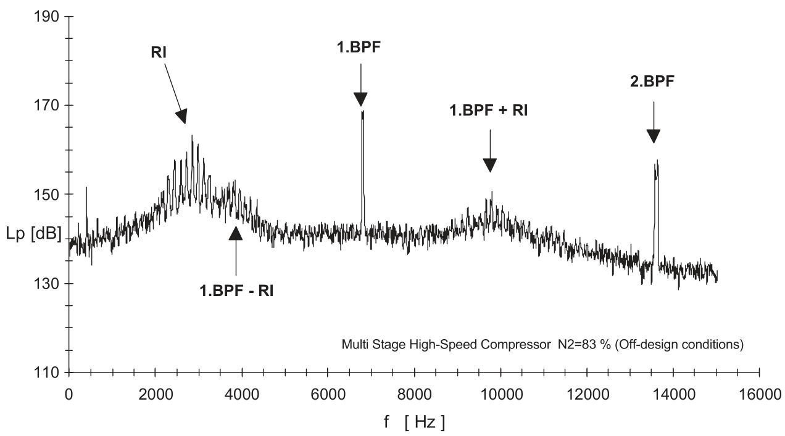 | 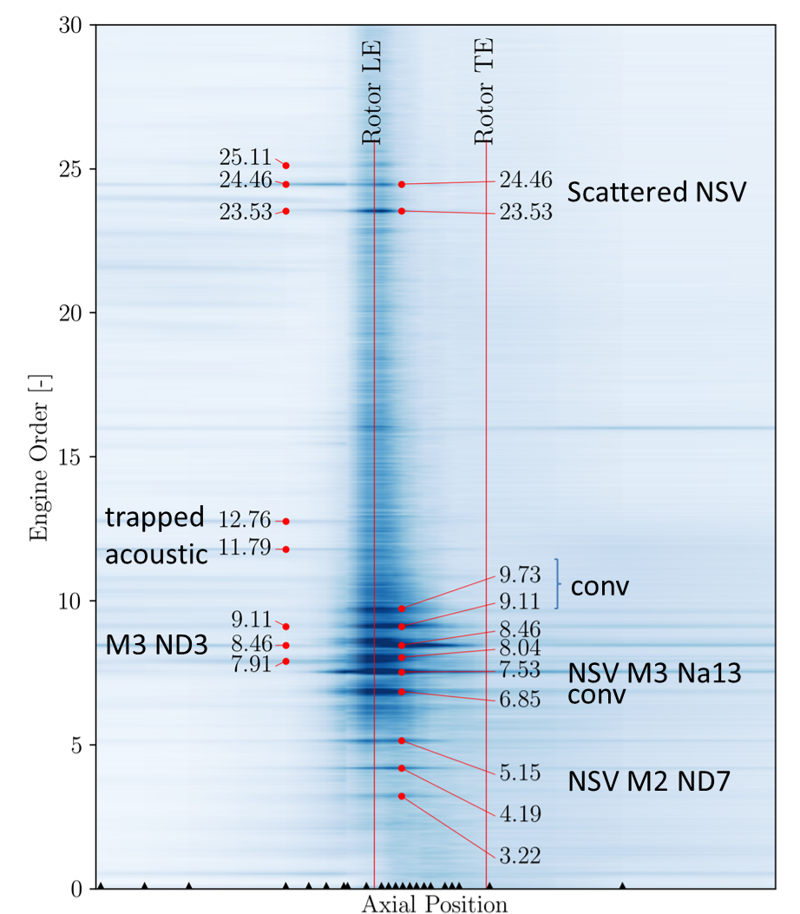
Figure 1 Pressure Spectrum from Baumgartner et al (1995) [1], showing frequency disturbance denoted as “Rotating Instability” | Figure 2 Pre-stall spectrum of a low speed fan, showing non-synchronous activity with peaks corresponding to convected disturbances, acoustic modes and fluid structure interaction
RESULTS and DISCUSSION
In the paper we will present the following points:
- A typical Rotating Instability spectrum can be explained by a frozen disturbance with constant propagation speed
- The established interpretation of a pulsating source with a characteristic RI-frequency is misleading
- Commonly used interpretations of measurements based on peaks in spectra is misleading, because lock-in with structural modes or acoustic modes is possible, and an overlap with forced response and Rotor-stator interactions as well as modulations with BPF harmonics may occur
- Spectrum generation is very sensitive to sensor integration and post-processing parameters (window length, subtraction of ensemble average, spectral averaging, etc )
- A robust method to determine waveforms and mode propagation speeds using multi-sensor cross correlation is presented
- At the specific example of a modern low-speed fan (low transonic) we show that a “typical” RI-spectrum contains peaks associated to pure aerodynamic disturbances, locked-in peaks due to Non-synchronous vibrations and resonating acoustic modes (example in Fig. 2). Without targeted post-processing methods as explained in the paper this decomposition, would not be possible. Also, commonly used interpretations would be misleading.
- We furthermore show that a model developed by the authors to predict the onset of Non-Synchronous-Vibrations [3] can be used to accompany the interpretation of measurement results and reproduce measured spectra.
References
[1] Baumgartner, Kameier und Hourmouziadis (1995). Non-engine order blade vibration in a high pressure compressor. Proceedings of ISABE
[2] Kameier, Neise (1997). Rotating blade flow instability as a source of noise in axial turbomachines, journal of sound and vibration
[3] Stapelfeldt, Brandstetter (2020). Non-synchronous vibrations in axial compressors. Lock-in mechanism and semi-analytical model, preprint available https://doi.org/10.13140/rg.2.2.16519.75688

